Unit 3 Grade 10 Applied
Equations of Lines

Lesson Outline

BIG PICTURE

Students will:
- Manipulate and solve algebraic equations, to solve problems;
- Graph a line and write the equation of a line from given information.
Day | Lesson Title | Math Learning Goals | Expectations
1 | Reminiscing Old Relationships | - Activate prior knowledge from grade 9 Applied on Linear Relations  - Collect data, create a scatter plot and line of best fit  - Make connections in context for initial value and the rate of change of a linear relation | ML2.01  CGE 3b, 5a
2 | Why Mr Y depends on Ms X? | - Identify that y = mx + b is a common form for the equation of a line.  - Make connections between the initial value and the rate of change in the relation to the y-intercept and slope of the equation of the line  - Identify the geometric significance of m and b in the equation y = mx + b.  - Write linear equations for relationships in context, e.g., an electrician charges $65 as a base fee and $35 for each hour.  - Given a linear equation in slope y-intercept form, write a story in context. | ML2.01  ML2.02  ML2.03  CGE 4f
3 | Slopes and Stuff | - Investigate the properties of the slopes of lines segments, using graphing calculators.  - Investigate the steepness of lines, from their graphs.  - Identify similarities and differences between lines with positive and negative slopes and parallel lines.  - Using GSP®4 and the plot points feature to find slopes of various lines to determine their characteristics. | ML2.03  ML2.04  CGE 5b, 5a
4 | Can Graphing Get Any Easier? | - Graph lines by hand using the y-intercept and slope given the equation in the slope y-intercept form | ML2.05  ML2.06  CGE 5b, 7b
5 | Temperature Conversions | - Determine a linear equation to convert between Celsius and Fahrenheit temperature  - Solve one variable equations with fractional coefficients in context using CAS and pencil and paper. | ML1.01  ML1.02

Day | Lesson Title | Math Learning Goals | Expectations
6 | Can You Stop the Fire? | - Create a scatter plot and line of best fit from collected data.  - Determine the equation of the line of best fit by hand.  - Verify the scatter plot and equation of line of best fit using technology  - Write linear equations for relationships in context from given information.  - Create contexts for given linear relations in slope y-intercept form. | ML2.01, ML2.02, ML2.03, ML2.04, ML2.06  CGE 3c, 4b
7. | Y the X Are You Intercepting Me? | - Determine the x and y intercepts of a linear relation.  - Determine the x and y intercepts of a linear relation in standard form.  - Graph lines in standard form by hand using the x and y intercepts.  - Solve linear equations involving one variable. | ML1.03  ML2.05
8. | Slopes Away | - Determine the equation of a line, given the slope and y-intercept  - Given two points, write the equation of a line.  - Determine the slope of the line using rate triangles and the formula. | ML1.01  ML1.03  ML2.05  ML2.06  CGE 5b
9 | Yes, we Have No Graph Paper | - Write the equation of a line given a point and a slope or two points  - Write linear equations for relationships in context. | ML1.01  ML2.06  CGE 5b
10. | So, You Think You Know Everything About Lines? | - Review x- and y-intercepts.  - Investigate the special cases x = a and y = b.  - Express the equation of a line in the form y = mx+b, given the form Ax + By + C = 0. | ML1.03  ML2.02  ML2.05  CGE, 5a, 5e
11 | London Bridge is Falling Down | - Collect data on linear relations in context of real-life problems  - Determine the equation of the linear relation  - Relate the slope and intercepts in the context of real-life applications  Note: This lesson could also be used as a summative performance task. | ML1.01- ML1.03  ML2.01- ML2.06  CGE 5b
12 | Summative Assessment | Sample unit review questions provided.  Note: A summative performance task is available from the members only section of the OAME web site www.oame.on.ca | MLV.001  MLV.002
13 | Jazz Day

Unit 3 Day 1: Reminiscing Old Relationships |  |  |  |  | Grade 10 Applied
Minds On: 20 Min. |  |  | Math Learning Goals  Students will:  - Activate prior knowledge from grade 9 Applied on Linear Relations  - Collect data, create a scatter plot and line of best fit  - Make connections in context for initial value and the rate of change of a linear relation |  | Materials  - Scissors  - Glue  - Envelopes  - BLM 3.1.1-BLM 3.1.8
Action: 40 Min.
Consolidate/
Debrief: 15 Min
Total = 75 Min.
Assessment
Opportunities
 | Minds On… | Pairs or Small Groups→Activating Prior Knowledge  Individually, students place definition terms in the appropriate location on BLM 3.1.1. In pairs or small groups students check their answers and form consensus on the answers.  Whole Class→Sharing  Share student responses and correct answers. |  |  | Cut out terms in advance or have students cut out terms individually  Be sure to cut out all the values and terms from BLM 3.1.5 and place them in appropriately labelled envelopes.  Assist students who are struggling, and provide additional clarification.
 | Action! | Pairs→A Coaches B  Assign heterogeneous pairs. Student A completes envelope A and C and student B completes envelope B and D from BLM 3.1.5. Have students glue or tape the values and terms from their envelopes to the appropriate boxes in BLM 3.1.4. Students then coach their partner.  Pairs→Investigating  Students gather data, create a scatter plot and line of best fit on BLM 3.1.6.  Learning Skill (Work Habits)/Observation/Anecdotal: Listen to students to determine their prior understanding of Linear Relations and observe students’ work habits.
 | Consolidate Debrief | Individual and Whole Class→Concept Map  Students first complete a Concept Map of the topics and definitions reviewed then students share their concept maps with the class. Create a class concept map. Example of a concept map is given in BLM 3.1.7
Application  Concept Practice |  | Home Activity or Further Classroom Consolidation  Students complete BLM 3.1.8.

3.1.1 Definition Match

Definitions:

An orderly arrangement of facts set out for easy reference (e.g., an arrangement of numerical values in vertical and horizontal columns)
The difference between two consecutive y-values in a table in which the difference between the x-values is constant
The vertical distance between two points
The horizontal distance between two points
A relation in which the graph forms a straight line
A relation in which one variable is a multiple of the other
A relation in which one variable is a multiple of the other plus a constant amount
The change in one variable relative to the change in another
The starting numerical worth or starting amount
A description of how two variables are connected
In a relation, the variable whose values you calculate; usually placed in the left column in a table and on the vertical axis in a graph

3.1.1 Definition Match (continued)

In a relation, the variable whose values you choose; usually placed in the right column in a table of values and on the horizontal in a graph
A line that best describes the relationship between two variables in a scatter plot
A symbol used to represent an unspecified number. For example, x and y are variables in the expression x + 2y
A relation whose graph is not a straight line

Graph:

= _____________________________
3.1.1 Definition Match (continued)

Equation

= x +

OR

= + x

Table of Values

Number of Weeks | Cost
0 | 65
10 | 75
20 | 85
30 | 95
40 | 105

= _____________________________
3.1.2: Definition Match - Teacher

Below are the values needed to fill the chart and blanks for the activity above. Make sufficient copies for every student. Cut these out, mix them up and place these into an envelope:


Dependent Variable | Dependent Variable | Dependent Variable | Dependent Variable
Dependent Variable | Direct Variation | First Differences | First Differences
Independent Variable | Independent Variable | Independent Variable | Independent Variable
Independent Variable | Initial Value | Initial Value | Initial Value
Initial Value | Initial Value | Line of Best Fit | Linear Relation
Non-linear Relation | Partial Variation | Rate of Change | Rate of Change
Rate of Change | Rate of Change | Rate of Change | Relation
Rise | Rise | Rise | Rise
Rise | Run | Run | Run
Run | Run | Table of Values | Variable

3.1.3 Definition Match – Solution

Definitions:

Table of Values | An orderly arrangement of facts set out for easy reference (e.g., an arrangement of numerical values in vertical and horizontal columns)
First Differences | The difference between two consecutive y-values in a table in which the difference between the x-values is constant
Rise | The vertical distance between two points
Run | The horizontal distance between two points
Linear Relation | A relation in which the graph forms a straight line
Direct Variation | A relation in which one variable is a multiple of the other
Partial Variation | A relation in which one variable is a multiple of the other plus a constant amount
Rate of Change | The change in one variable relative to the change in another
Initial Value | The starting numerical worth or starting amount
Relation | A description of how two variables are connected
Independent Variable | In a relation, the variable whose values you calculate; usually placed in the left column in a table and on the vertical axis in a graph

3.1.1 Definition Match – Solution (Continued)

Dependent Variable | In a relation, the variable whose values you choose; usually placed in the right column in a table of values and on the horizontal in a graph
Line of Best Fit | A line that best describes the relationship between two variables in a scatter plot
Variable | A symbol used to represent an unspecified number. For example, x and y are variables in the expression x + 2y
Non-Linear Relation | A relation whose graph is not a straight line

Graph
Run

Dependent Variable
Dependent Variable

Rise

Initial Value

Independent Variable

Rise
Rate of Change
= _____________________________
Run
3.1.1 Definition Match – Solution (Continued)

Equation
Independent Variable
Initial Value
Rate of Change
Dependent Variable
= x +

OR

Independent Variable
Dependent Variable
Initial Value
Rate of Change
= + x

Table of Values
Dependent Variable
Independent Variable

Initial Value

Number of Weeks | Cost
0 | 65
10  Run | 75  Rise
20 | 85
30 | 95
40 | 105

First Differences

Rise
Rate of Change
= _____________________________
Run

3.1.4: Reminiscing Old Relationships

There are 4 different envelopes that match the relationships below. Partner A will work on ENVELOPES A and C, Partner B will work on ENVELOPES B and D. Your job is to glue the appropriate values from your envelope onto the space provided.
ENVELOPE A
Another Banquet Hall  A banquet hall charges a flat rate of $300 plus $20 per person. | Earning Money  Lindsay earns $10 per hour.
Initial Value: | Initial Value:
Rate: | Rate:
Independent Variable: | Independent Variable:
Dependent Variable: | Dependent Variable:

ENVELOPE B
Money, Money!  Ayda receives a base salary of $200 and $50 for every audio system he sells. | Internet Fees  An internet package charges a flat fee of $10 plus $0.40 per hour.
Initial Value: | Initial Value:
Rate: | Rate:
Independent Variable: | Independent Variable:
Dependent Variable: | Dependent Variable:

3.1.4: Reminiscing Old Relationships (Continued)

ENVELOPE C
A Runner’s Time | Cost of Renting a Bus
  Time  (s) | Distance  (m)
  0 | 0
  1 | 2
  2 | 4
  3 | 6
  4 | 8
Initial Value: | Initial Value:
Rate: | Rate:
Independent Variable: | Independent Variable:
Dependent Variable: | Dependent Variable:

3.1.4: Reminiscing Old Relationships (Continued)

ENVELOPE D
Running Up The Stairs | Cost of Renting a Boat
  Time (s) | Cost of Bus Charter ($)
  0 | 10
  1 | 12
  2 | 14
  3 | 15
  4 | 16
Initial Value: | Initial Value:
Rate: | Rate:
Independent Variable: | Independent Variable:
Dependent Variable: | Dependent Variable:

3.1.5: Reminiscing Old Relationships - Teacher

Below are the values needed to fill the charts for the activity above. Cut these out, mix them up and place these into separate envelopes:

Note: Paste the envelope name on the outside of the envelope


ENVELOPE A

300 | 0
20 | 10
Number of People | Time
Cost | Earnings


ENVELOPE B

200 | 10
50 | 0.40
Number of Audio Systems | Time
Earnings | Cost

3.1.5: Reminiscing Old Relationships -Teacher (Continued)

Below are the values needed to fill the charts for the activity above. Cut these out, mix them up and place these into separate envelopes:


ENVELOPE C

0 | 100
2 | 1
Distance | Cost
Time | Distance


ENVELOPE D

10 | 10
2 | 20
Cost | Cost
Time | Time (Days)

3.1.6: A Mathematical Spelling Bee

Procedure

- You will work in partners where Partner A is the timer and Partner B is the recorder.

- Create four quadrants by folding a piece a paper in half and fold in half again.

- With a watch, student A will signal student B to start printing the full word RUN down one of the paper quarters as many times possible in 10 seconds. This is not a contest print at your normal printing speed.

- After 10 seconds, student B signals student A to stop printing.

- Count all the legible words.

- Record this value in the table below.

- Repeat steps 1 – 6 for the words RATE, VALUE, CHANGE and INITIAL

Recording Data

- Record this value in the table below.

Word | Word Length | Number of Words Written
RUN
RATE
VALUE
CHANGE
INITIAL

- What is the independent variable?

- What is the dependent variable?

3.1.6: A Mathematical Spelling Bee (Continued)

- Create a scatter plot from your data on the grid provided. Label the axis with the independent variable on the x-axis and dependent variable on the y-axis.

- Draw a line of best fit from the scatter plot above. Extend your line to both the x-axis and y-axis.

- Using a rate triangle, calculate the rate of change of your line of best fit. ____

- Interpret the meaning of the rate of change as it relates to this activity.

- At what value does the line cross the y-axis?

- Interpret this value in the context of this activity.

- At what value does the line cross the x-axis??

- Interpret this value in the context of this activity.

3.1.7: Linear Relation Concept Map – Teacher

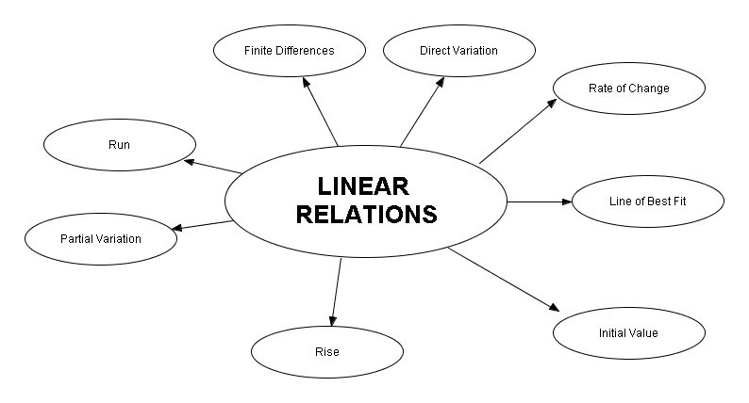
3.1.8: Variables and Equations with Graphs

For each of the following graphs determine:
- The rate and the initial value from the graph. Show your work on the graph.
- A rule in words that relates the balance (B), the number (n) of weekly withdrawals or deposits and the initial amount in the account; and
- An algebraic rule relating Balance (B), the number of weekly withdrawals/deposits (n) and the initial value in the account
- Determine how much will be in the account after 12 weeks using the formula.

1. This person is withdrawing/depositing that is positive/negative correlation. Circle correct answers.

B  n  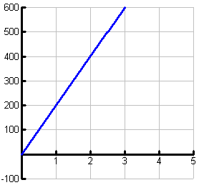 |  | b) Rule in words:  Balance starts at _______ and ________(increase/decrease)by _________per week(rate).  c) Algebraic Rule  B =  d) After 12 weeks.

2. This person is withdrawing/depositing that is positive/negative correlation. Circle correct answers.

B  n  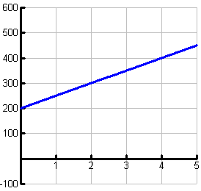 |  | b) Rule in words:  Balance starts at _______ and ________(increase/decrease)by _________per week(rate).  c) Algebraic Rule  B =  d) After 12 weeks.
3.1.8: Variables and Equations with Graphs (Continued)

3. This person is withdrawing/depositing that is positive/negative correlation. Circle correct answers.

B  n  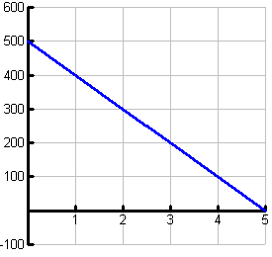 |  | b) Rule in words:  Balance starts at _______ and ________(increase/decrease)by _________per week(rate).  c) Algebraic Rule  B =  d) After 12 weeks.

On a graph, the initial value is shown as the ________________________________________

On a graph, the rate is shown as _________________________________________________

4. This person is withdrawing/depositing that is positive/negative correlation. Circle correct answers.

B  n  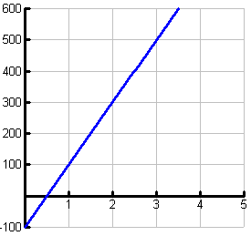 |  | b) Rule in words:  Balance starts at _______ and ________(increase/decrease)by _________per week(rate).  c) Algebraic Rule  B =  d) After 12 weeks.

3.1.8: Variables and Equations with Graphs (Continued)

5. This person is withdrawing/depositing that is positive/negative correlation. Circle correct answers.

B  n  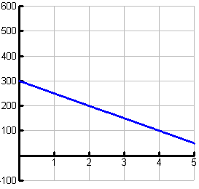 |  | b) Rule in words:  Balance starts at _________ and _________by _________ per week.  c) Algebraic Rule  B =  d) After 12 weeks.

6. This person is withdrawing/depositing that is positive/negative correlation. Circle correct answers.

B  n  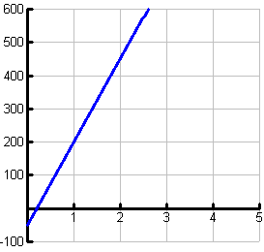 |  | b) Rule in words:  Balance starts at _________ and _________by _________ per week.  c) Algebraic Rule  B =  d) After 12 weeks.

Unit 3 Day 2: Why Mr Y depends on Ms X? |  |  |  |  | Grade 10 Applied
Minds On: 5 Min. |  |  | Math Learning Goals  Students will:  - Identify that y = mx + b is a common form for the equation of a line.  - Make connections between the initial value and the rate of change in the relation to the y-intercept and slope of the equation of the line  - Identify the geometric significance of m and b in the equation y = mx + b.  - Write linear equations for relationships in context, e.g., an electrician charges $65 as a base fee and $35 for each hour.  - Given a linear equation in slope y-intercept form, write a story in context. |  | Materials  - Computer and projector  - BLM 3.2.1 – 3.2.4
Action: 40 Min. |  |  |  |  | Materials  - Computer and projector  - BLM 3.2.1 – 3.2.4
Consolidate/  Debrief: 30 Min |  |  |  |  | Materials  - Computer and projector  - BLM 3.2.1 – 3.2.4
Total = 75 Min. |  |  |  |  | Materials  - Computer and projector  - BLM 3.2.1 – 3.2.4
Assessment
Opportunities
 | Minds On… | Whole Class→Agree or Disagree  Create an overhead transparency of BLM 3.2.1. For each question students either stand (agree) or remain sitting (disagree). Students debate who is correct with reasons. Record class consensus on BLM. |  |  | Think Literacy:  Four Corners Variation – Opposite Sides – pg 79  Y-int Slope Form.ppt  Only show the equation of the lines in the presentation, do not ask students to determine the equations. Students are to make connections not determine the equation.
 | Action! | Whole Class→Presentation and Investigation  Using electronic presentation, Y-int Slope Form, present the connections between the initial value and the rate of change in the relation to the y-intercept and slope of the equation. Students use BLM 3.2.2 to record.
 | Consolidate Debrief | Individual/Pairs→Graphic Organizer  Students are to complete individually BLM 3.2.4 at first then share their graphical organizer with another to confirm correct understanding.  Curriculum Expectations/Observation/Mental Note: Observe if students recognize the geometric significance of m and b in the equation y = mx + b and the connections between the initial value and the rate of change.
Application |  | Home Activity or Further Classroom Consolidation  Complete BLM 3.2.4

3.2.1: Agree to Disagree

For each question stand if you agree or remain sitting if you disagree. | Class Consensus  (Agree / Disagree)
a) Point A has coordinates (3, -2)  b) Point B has coordinates (3, 4)  c) Point C has coordinates (-1, 1)  d) Point A is in Quadrant 4  e) The origin is located at (0, 0) | a)
 | b)
 | c)
 | d)
 | e)
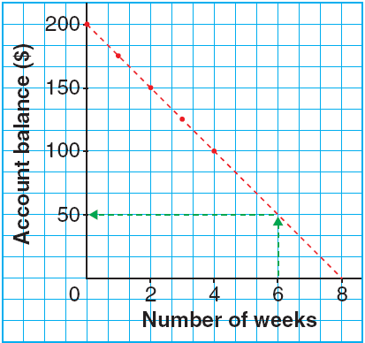  a) The rate of change is $25/week  b) The initial value is $200 | a)
 | b)

3.2.1: Agree to Disagree (Continued)

For each question stand if you agree or remain sitting if you disagree. | Class Consensus  (Agree / Disagree)
A family meal deal at Chicken Deluxe costs $26, plus $1.50 for every extra piece of chicken added to the bucket.  a) The rate of change is $26.  b) The initial value is 426.  c) The independent variable is number of pieces of chicken | a)
 | b)
 | c)
A Chinese food restaurant has a special price for groups. Dinner for two costs $24 plus $11 for each additional person.  a) The rate of change is $11  b) The initial value is $11  c) The dependent variable is the number of people | a)
 | b)
 | c)
a) The initial value is 9.40  b) The rate of change is $1.10  c) Dependent variable is the Cost of a Large Pizza | a)
  Number of Toppings | Cost of a Large Pizza ($)
  0 | 9.40
  1 | 11.50
  2 | 13.60
  3 | 15.70
  4 | 17.80
 | b)
 | c)

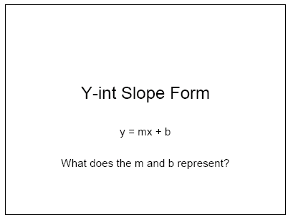
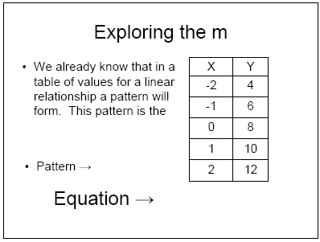
3.2.2: Exploring an MB Eh!
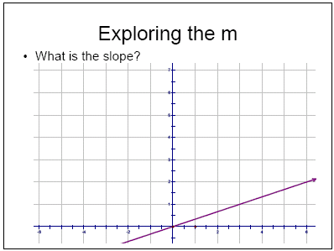
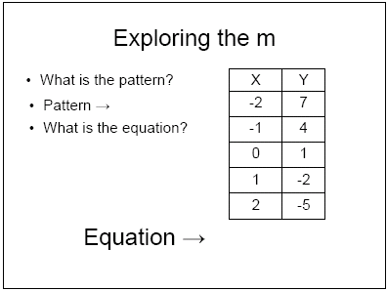
3.2.2: Exploring an MB Eh! (Continued)
3.2.2: Exploring an MB Eh! (Continued)
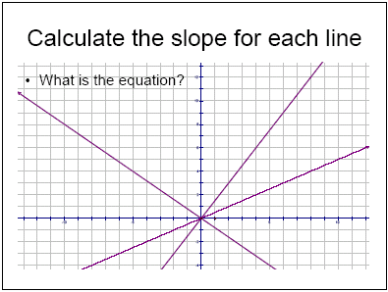
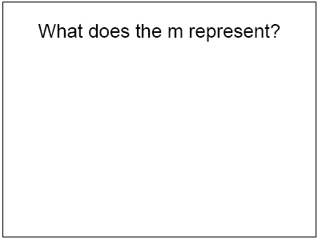
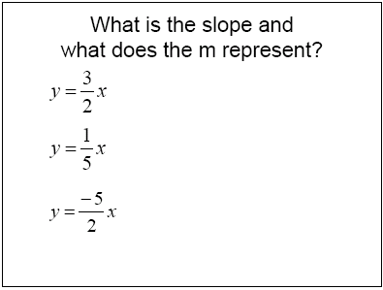
3.2.2: Exploring an MB Eh! (Continued)
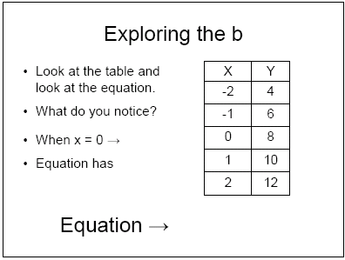
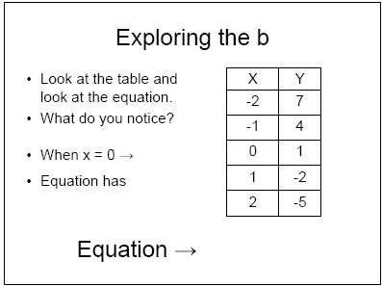
3.2.2: Exploring an MB Eh! (Continued)
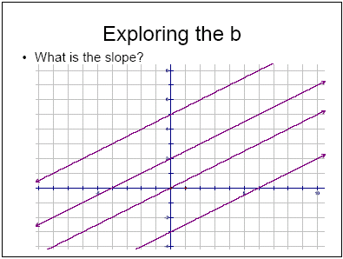
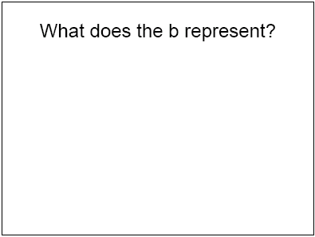
3.2.2: Exploring an MB Eh! (Continued)
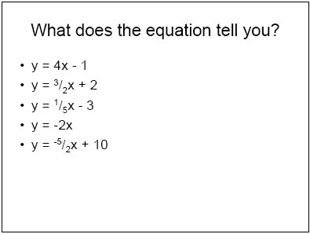
3.2.2: Exploring an MB Eh! (Continued)
3.2.3: Presentation Y-int Slope Form
Y-int Slope Form.ppt

1 | 2
3 | 4
5 | 6
7 | 8

3.2.3: Presentation Y-int Slope Form (Continued)

9 | 10
11 | 12
13

3.2.4: Why Mr. Y depends on the independent Ms. X?

Complete the tables on the next two pages that compare and contrast terms, equations, tables of values and graphs between grade 9 and grade 10.

Grade 9 Topics – Initial Value, Rate of Change, Independent and Dependent Variable | New Grade 10 Topics – y-intercepts, slope, x and y | Similarities | Differences
Terminology
Equation

3.2.4: Why Mr. Y depends on the independent Ms. X? (Continued)

Grade 9 Topics – Initial Value, Rate of Change, Independent and Dependent Variable | New Grade 10 Topics – y-intercepts, slope, x and y | Similarities |  | Differences
Table of Values
Graphs

3.2.4: Why Mr. Y depends on the independent Ms. X? (Continued)

Complete the following table for each equation given. Provide a different context for each row if possible.

Equation | Slope | Real Context for Slope | y-intercept | Real context for y-intercept | Real context equation
Y = 2.5x + 5 | 2.5 | $2.50/km | 5 | $5 starting fee | C = $2.50d + $5  (C represents cost and d represents distance a cab travels)
Y = 2x + 17
y = 250 – 10x
y = 1.5 + x
y = 100x – 2000
y = 75x
Unit 3 Day 3: Slopes and Stuff |  |  |  |  | Grade 10 Applied
Minds On: 5 Min. |  |  | Math Learning Goals  Students will:  - Investigate the properties of the slopes of lines segments, using graphing calculators.  - Investigate the steepness of lines, from their graphs.  - Identify similarities and differences between lines with positive and negative slopes and parallel lines.  - Using GSP®4 and the plot points feature to find slopes of various lines to determine their characteristics. |  | Materials  - BLM 3.3.1 – 3.3.8  - Graphing calculators  - Computers with GSP®4  - Scissors
Action: 60 Min.
Consolidate/
Debrief: 10 Min
Total = 75 Min.
Assessment
Opportunities
 | Minds On… | Pair→Pair/Share  Assign heterogeneous pairs.  Partner A: tells Partner B what a slope is.  Partner B: tells Partner A what y-intercept is.  Together: please make up an equation in the y=mx+b form  Whole Class→Discussion  Discuss and review what slope and y-intercept is and review  y = mx + b |  |  | Refer to BLM 3.3.7 for the teacher instructions on using Transfrm application for  TI-83+/TI-84.  If graphing calculators are not available, instructions have been written and included for GSP®4. Note: Students worksheets/activities are different than the worksheets for TI-83. Check BLM 3.3.8 for teacher instructions and BLM 3.3.5 for students.
 | Action! | Individual→Transfrm Tutorial  Cut out equations from BLM 3.3.3 and randomly distribute to each student. Distribute graphing calculators to students. Students follow instructions on BLM 3.3.1 and complete the first 10 questions on BLM 3.3.2  Whole Class→Parallel Lines Investigation  Students continue from page 3 on BLM 3.3.2 and, using the graphing calculator to verify, they will find other students whose lines are parallel.
 | Consolidate Debrief | Whole Class→Guided Discussion  Encourage pairs whose lines are parallel to identify themselves and sharing their equations with the group.  Lead a discussion concluding the conditions for lines to be parallel.
Application  Concept Practice |  | Home Activity or Further Classroom Consolidation  Students complete BLM 3.3.6. Students name the slopes (AB, BC, etc.), indicate whether it is a positive or negative slope and find parallel slopes (if any).

3.3.1 Slopes and Stuff on TI-83

Instructions for TI-83
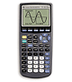
Ok, if you follow this step-by-step, it will be fool-proof. Let’s start!

Press ON
Press APPS
Scroll and find TRANSFRM
Press ENTER
Select UNINSTALL by pressing ENTER
Press APPS again
Scroll and find TRANSFRM
Press ENTER
Now the screen should say “PRESS ANY KEY”, so press any key to continue
Your screen will say DONE
Press Y= (grey button, white font, top left)

You now need to enter AX+B.
Do you see all the green letters on the calculator? You can get to them by pressing the ALPHA button (green button, white font)
So, to get A, you need to press ALPHA, then MATH. See?
X is the button to the right of the ALPHA button (the button with X,T,Ө,n)
The “+” sign you can find for sure and can you figure out how to type B?

So now you should have AX+B entered on the screen!
A few more steps and we’re ready to graph.
Press WINDOWS
Scroll up once so that SETTINGS is highlighted
Scroll down and change A to 1, change B to 1 and change Step to 1.
Ok, you’re ready!

Press GRAPH!

Scroll right and left to see what happens to A.
If you want to play with B, scroll down once so that the equal sign for B is highlighted and then scroll right and left as well to change B.

Picture Source:http://education.ti.com/educationportal/sites/US/productCategory/us_graphing.html
3.3.2 Slopes and Stuff on TI-83 Investigation

Worksheet for graphing calculator

1. Describe the graph when A is greater than 1. | Draw an example.
2. What is the difference between A = 2 and A = 6? | Draw A = 2 on the left and draw A = 6 on the right.
3. What happens when A = 0? | Draw an example.
4. Describe the graph when A is less than 0. | Draw an example.
5. What is the difference between A =  -2 and A = -6? | Draw A = -2 on the left and draw A = -6 on the right.

3.3.2 Slopes and Stuff on TI-83 Investigation
(continued)

6. When you are changing A, what stayed the same?

7. What happens when B = 5? | Draw an example.
8. What happens when B = -6? | Draw an example.
9. When you are changing B, what stayed the same?

10. In the equation y = mx + b, what does letter A represent? What about B?

3.3.2 Slopes and Stuff on TI-83 Investigation
(continued)

Almost done. But since we’re finished with the Transform applications, please help me uninstall it first before we move on.

Press APPS
Scroll and find TRANSFRM
Press ENTER
Select UNINSTALL by pressing ENTER

Using your equation that you got from your teacher, type this into your graphing calculator.

Press Y= and enter the equations (remember, X is the button with X,T,Ө,n ).
Press GRAPH

You should see your graph on your screen. Walk around the room and find a line that looks parallel to yours from another student. If you want to see whether the lines are parallel, type the equation from the student you found into your calculator as well. Just repeat the above instructions and enter the second equation into Y₂ = . Press GRAPH again.

Are they similar? If they are, compare the two equations. What is the same?

What can you conclude about parallel lines?

Check this by finding another pair of students and discuss your conclusions briefly with them.

Write down your conclusion below.
3.3.3 Cutouts for second part of TI-83 Activity - Teacher


y = x + 1 | y = x + 2 | y = 2x + 1
y = 2x + 2 | y = 3x + 1 | y = 3x + 2
y = 4x + 1 | y = 4x + 2 | y = 5x + 1
y = 5x + 2 | y = 6x + 1 | y = 6x + 2
y = -x + 1 | y = -x + 2 | y = -2x + 1
y = -2x + 2 | y = -3x + 1 | y = -3x + 2
y = -4x + 1 | y = -4x + 2
3.3.4 Slopes and Stuff on GSP– Optional Investigation


Student Instructions for GSP

Ok, Geometer’s Sketchpad is a great way to see just how the slope and y-intercepts work. Follow these instructions and they will help you create what you need in order for you to start investigating. Good luck!

First, let’s launch Geometer’s Sketchpad on the computer. Click on any white space to get rid of the logo.

Let’s see some grid. Select Show Grid from the Graph menu. Great, now we’re ready to create a line.

Select Plot Points from the Graph menu.
Enter 0 (left text box), and 1 (right text box).
Click Plot. Click Done.

Click on the Point Tool on the left hand side menu.
Create a point anywhere you want.

Click and hold the Line Tool on the left hand side menu until a line with arrows on both ends appear and select that option. Click on point (0,1) and click on the point that you created to create a line.

Click on the Arrow Tool on the left hand side menu and click on any white space. Now click on the line so that only the line is highlighted.

Select Slope from the Measure menu. Click on any white space. Click on the line. If you point your cursor on Point B, you can now click and drag the line! Look at the slope number!

Answer questions 1 – 6 on the worksheet. ☺

Now that you have looked at the slope, let’s look at the y-intercept.

Select New Sketch from the File menu. Let’s show some grid first (see instructions above).

Now, click on the Point Tool on the left hand side and create a point anywhere on the y-axis. Select Translate from the Transform menu. On the pop-up menu, click on Rectangular on the top. Enter 3 for Horizontal and 2 for Vertical (or any one-digit number that you want). Click Translate.

Select the Arrow Tool on the left hand side menu and click on any white space. Click on the point on the y-axis to highlight it and select Ordinate (y) from the Measure menu. Click on any white space.

3.3.4 Slopes and Stuff on GSP – Optional Investigation
(continued)

Create a line with those two points (see instructions above). After you have created the line, click on any white space and then highlight the line. Select Slope from the Measure menu. Click on any white space and then highlight the line again.

Now as you move the line, look at the y-ordinate number and look at the slope value.

Answer questions 7 – 10 on the worksheet. ☺

Ok, a little bit more and the activity is done. But first, we need to create another line.

Click on the Point Tool on the left hand side again and create a point anywhere on the y-axis again. Select Translate from the Transform menu. On the pop-up menu, you should have your prior numbers on there already. If not, translate this point the same as your last point. Click Translate.

Again, click on the Line Tool on the left hand side and create a new line with the two new points that you have. Select the Arrow Tool on the left hand side, click on any white space, highlight the new line and Measure the Slope of the new line. Click on any white space.

Answer question 11 on your worksheet. ☺

Highlight Point A and Point B. Measure the Coordinate Distance. Click on any white space.

Measure the Coordinate Distance for Point A’ and B’ as well. Click on any white space.

Answer the rest of the questions on your worksheet. ☺

Picture source: http://www.wiley.com/college/musser/CL_0471263796_S/sketchpad/sketchpad_tutorial/
3.3.5 Slopes and Stuff on GSP – Optional Investigation

Worksheet for GSP

1. Describe the graph when the slope is greater than 1. | Draw an example.
2. What is the difference between the slope = 2 (approximately) and the slope = 6 (approximately)? | Draw slope = 2 on the left and draw slope = 6 on the right.
3. What happens when slope = 0? | Draw an example.
4. Describe the graph when slope is less than 0. | Draw an example.
5. What is the difference between slope = -2 and slope = -6? | Draw slope = -2 on the left and draw slope = -6 on the right.

3.3.5 Slopes and Stuff on GSP – Optional Investigation
(continued)

6. When you are changing the slope, what stayed the same?

7. What happens when the y-ordinate  = 5? | Draw an example.
8. What happens when the y-ordinate  = -6? | Draw an example.
9. When you are changing the y-ordinate, what stayed the same?

10. In the equation y = mx + b, which letter does slope represent? What about the y-ordinate?

3.3.5 Slopes and Stuff on GSP – Optional Investigation
(continued)

11. What do you notice about these two lines?

12. What do you notice about the two coordinate distances? | Write down the two coordinate distances here.
13. Because the two coordinate distances are the same, what does that mean about the two lines? | Was your hypothesis correct from question 11?

3.3.6 Slopes and Stuff Homework

From the graph below, label each point with a name (A, B, etc.), name each slope, state whether the slope is positive or negative, calculate the slope and state any parallel slopes.

0
5
10
15
20
0
1
2
3
4
5
Time (h)
Distance (km)m)

Slope: ______________________________________________________________________

Slope: ______________________________________________________________________

Slope: ______________________________________________________________________

Slope: ______________________________________________________________________

Slope: ______________________________________________________________________

Parallel slopes? _______________________________________________________________
3.3.7 Teacher Instructions for Transfrm on the TI-83+/TI-84

Teacher Instructions for TI-84:

Press APPS, scroll and find TRANSFRM
Press ENTER
Press UNINSTALL
Press APPS, scroll, find and press TRANSFRM

Now you will see…  Press any key to continue | 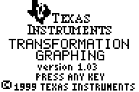
Blank screen appears again | 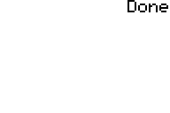
Press Y= | 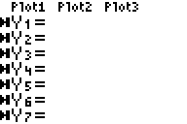
Under Y1 =, enter AX+B by pressing ALPHA, press MATH, press X,T,Ө,n, press +, press ALPHA, press APPS | 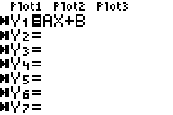
Press WINDOWS | 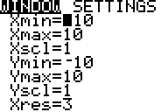
3.3.7 Teacher Instructions for Transfrm on the TI-83+/TI-84 (continued)

Scroll up so that SETTINGS is now highlighted and the SETTINGS menu comes on the screen | 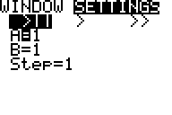
Scroll down until the number beside A is highlighted and enter 1.
Enter 1 for B as well.
Enter 1 for Step as well.
Press GRAPH. The equal sign for A is highlighted | 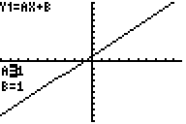
By scrolling to the RIGHT, the value of A will increase and by scrolling to the LEFT, the value of A will decrease | 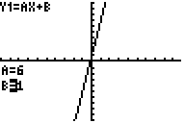  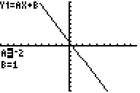
Scroll DOWN to highlight the equal sign for B. | 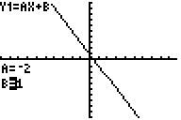
3.3.7 Teacher Instructions for Transfrm on the TI-83+/TI-84 (continued)

Likewise, scroll RIGHT to increase the value of B and LEFT to decrease the value of B. | 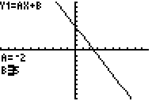  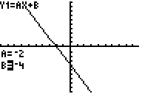

3.3.8 Teacher Instructions for GSP

Teacher instructions for GSP (slope investigation):

Launch GSP on the computer | 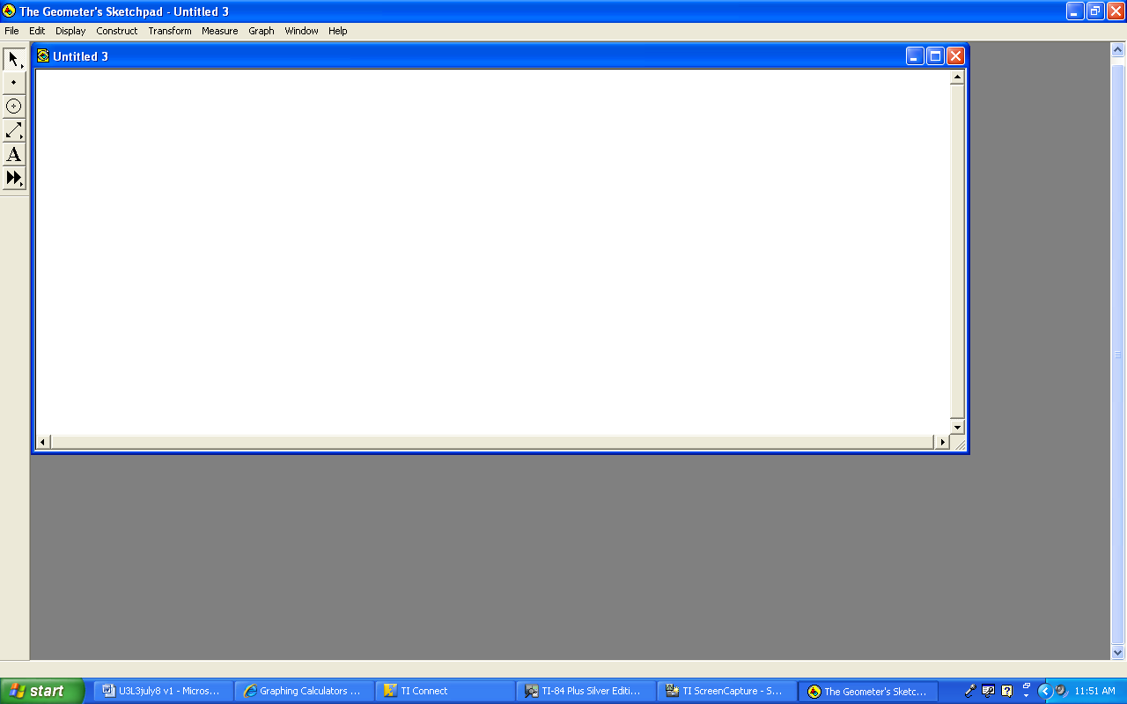
Select Show Grid from the Graph menu | 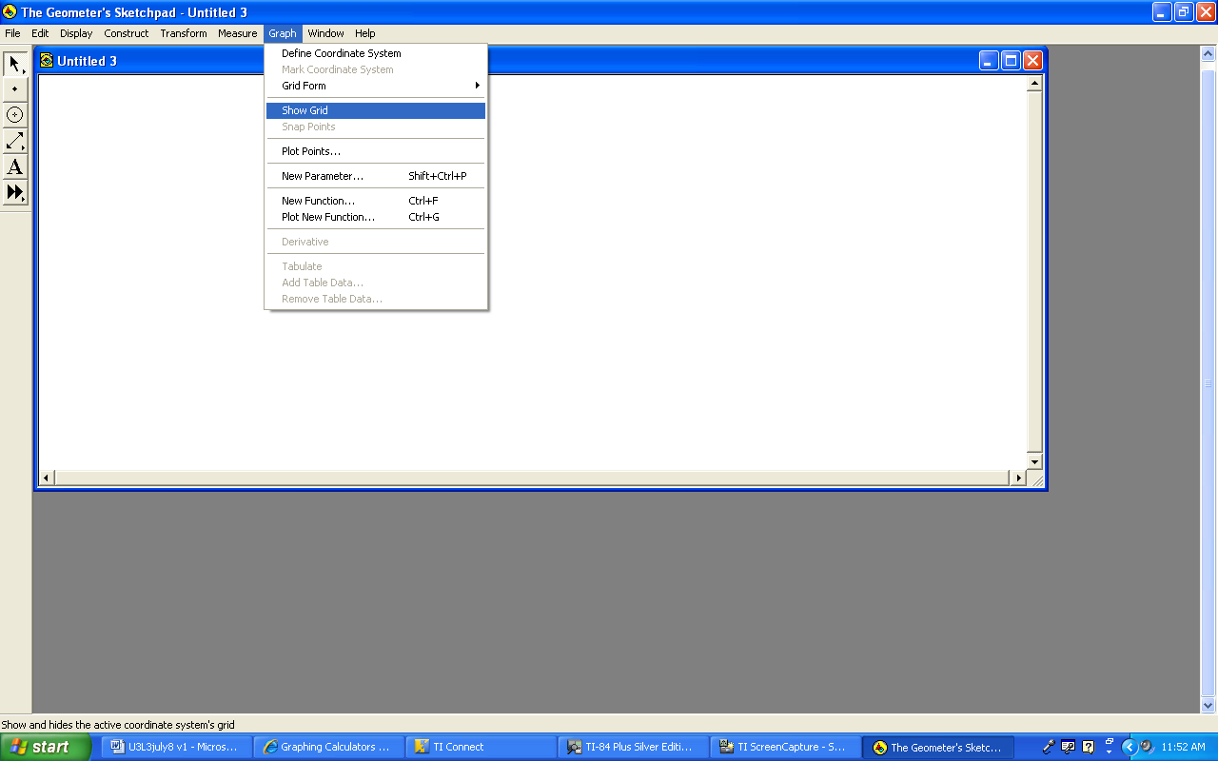
Now grids will show. | 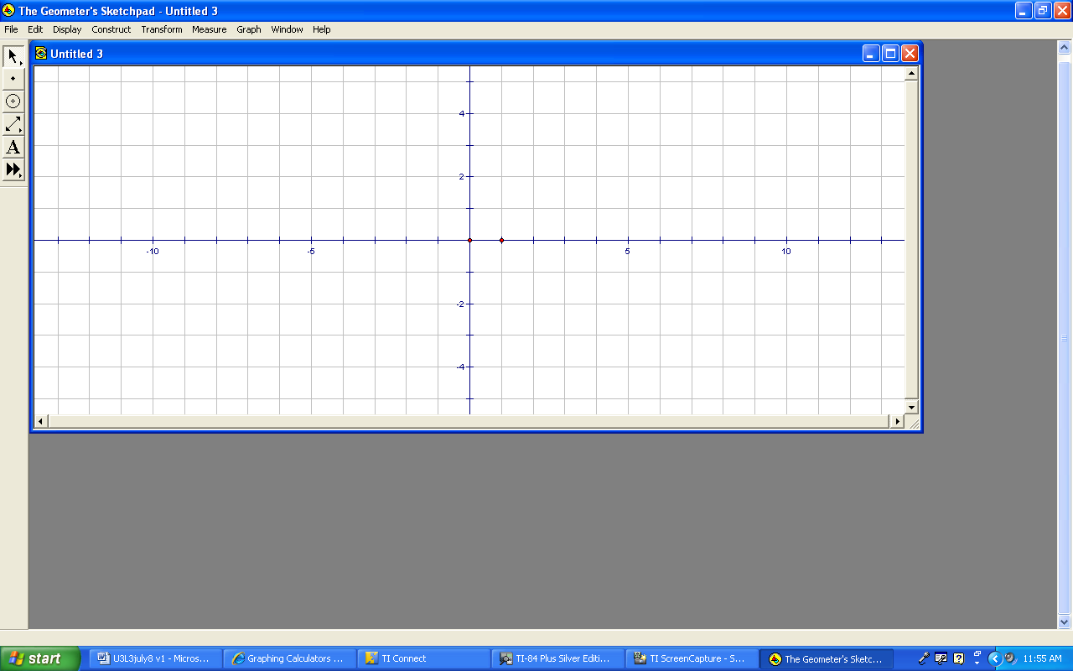
Plot (0,1) by selecting Plot Points under the Graph menu. Enter 0, and then 1, and press PLOT. Then click DONE. | 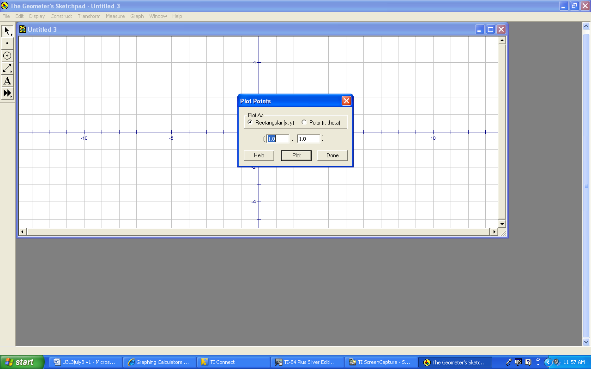
3.3.8 Teacher Instructions for GSP (continued)

Click on the Point Tool on the left hand side menu and click anywhere on the grid to create a point. | 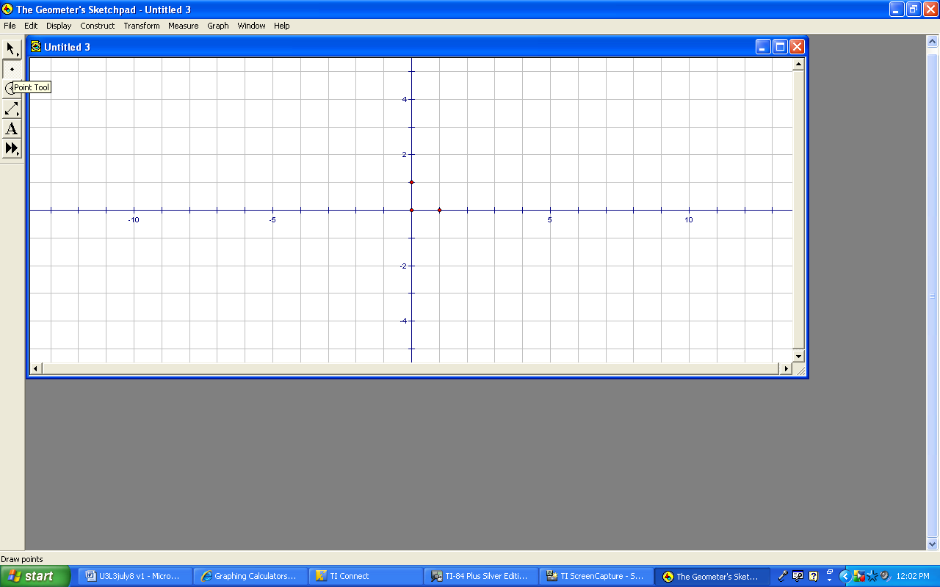
Click and hold on the Straightedge Tool until you see the continuous line (line with arrows on both ends) and select that one. | 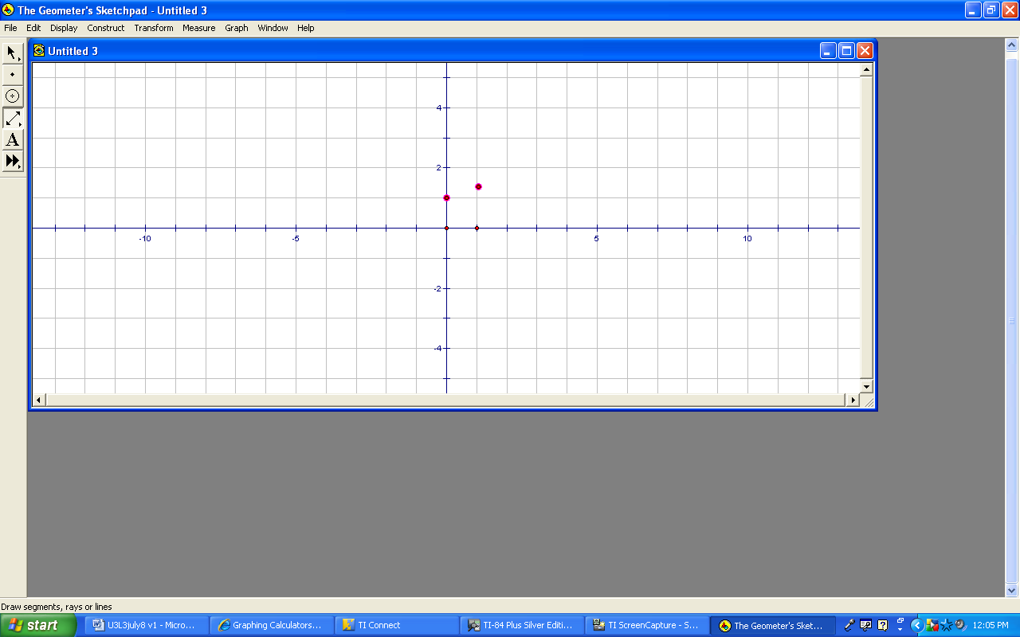
Click on the point on (0,1) and click on the point you just created and a line will appear connecting the two points. | 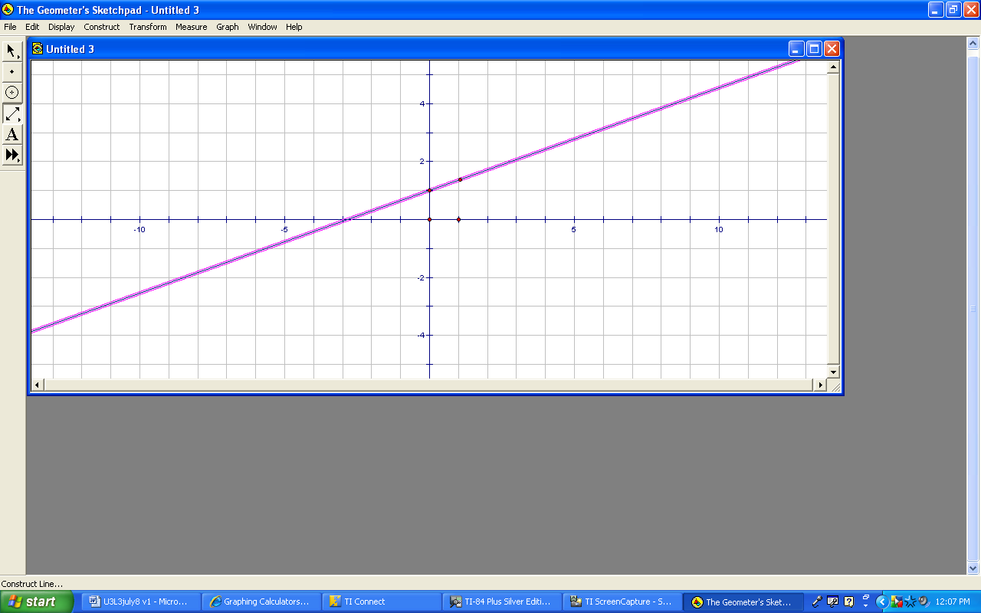
Click on the Select Arrow Tool. Click on any white space. Now click on the line only. | 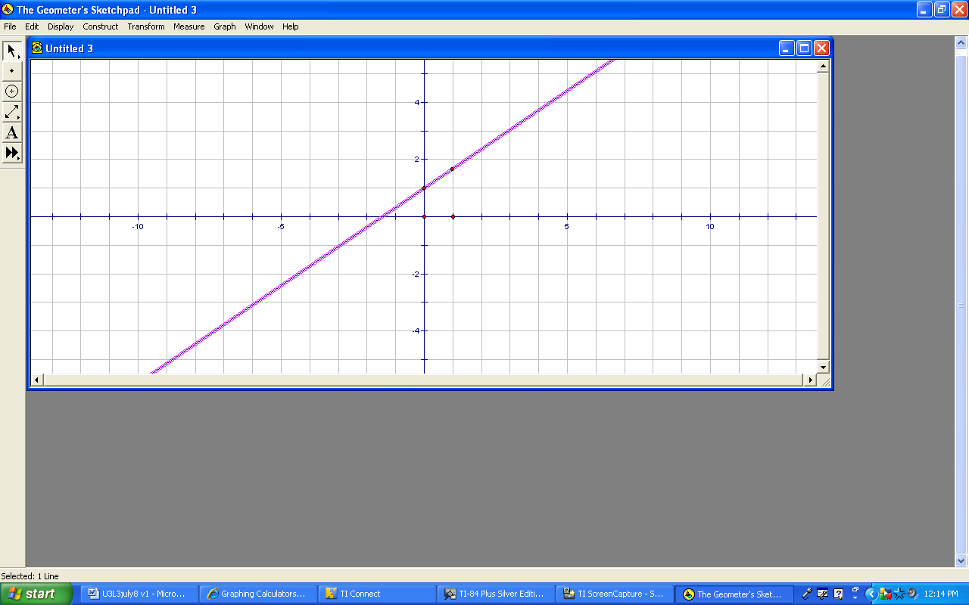
3.3.8 Teacher Instructions for GSP (continued)

Select Slope from the Measure menu. | 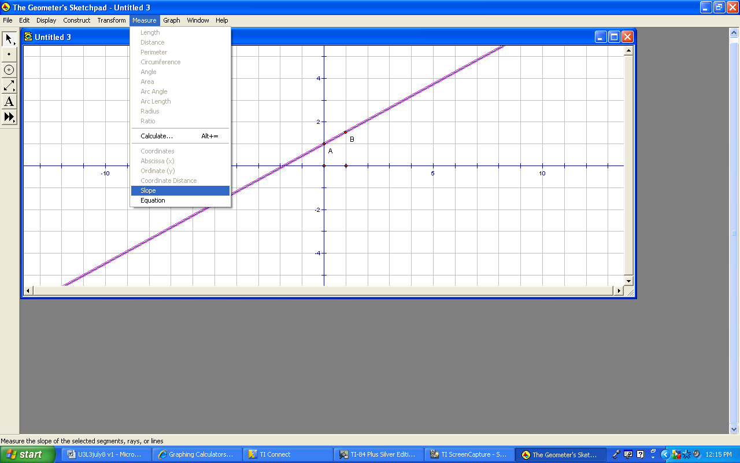
Click anywhere on the white space. Then click on Point B. You can now drag Point B around and the slope (in the measurement box) will change accordingly. | 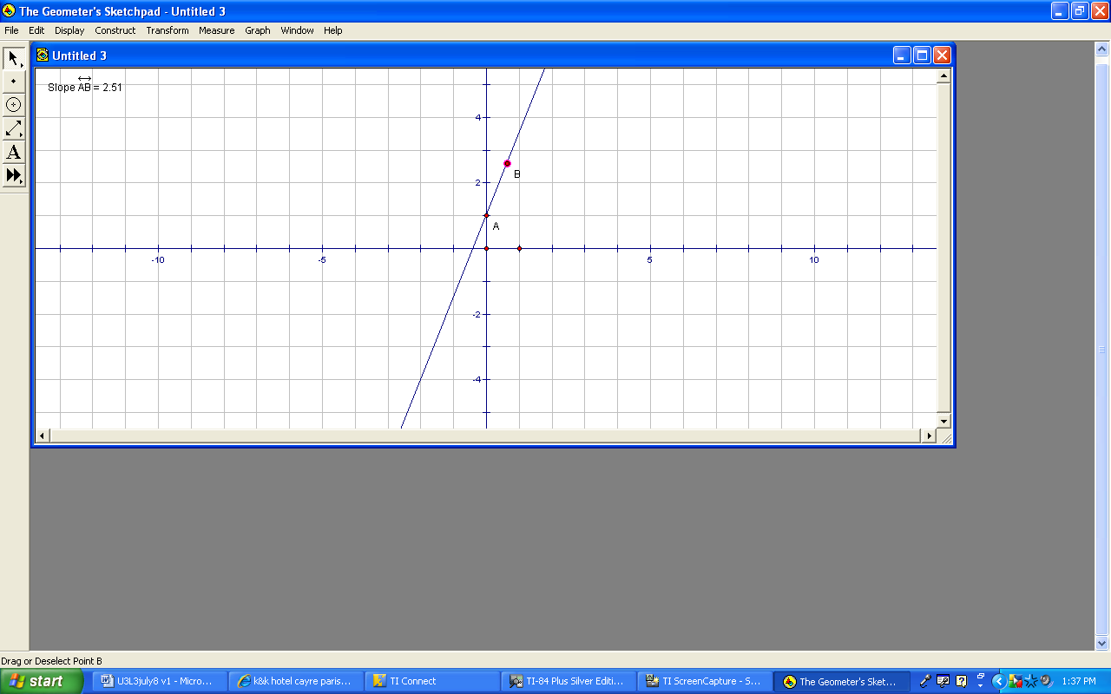

Teacher instructions for GSP (y-intercept investigation):

Select New Sketch from the File menu. | 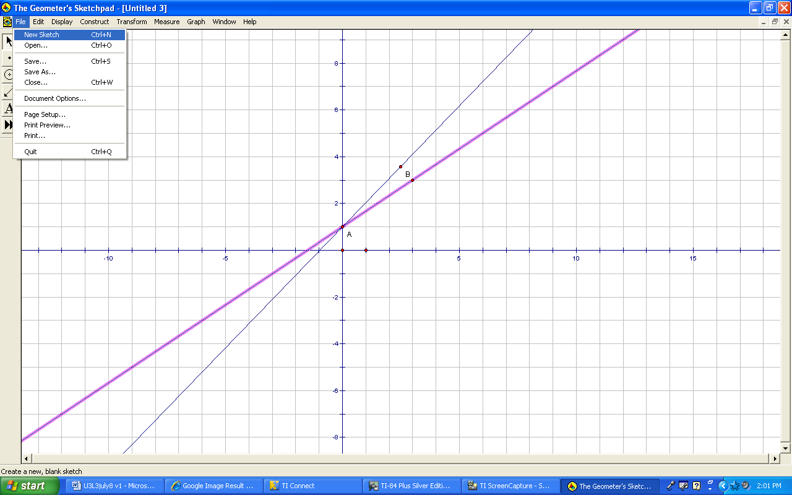
3.3.8 Teacher Instructions for GSP (continued)

Select Show Grid from the Graph menu. | 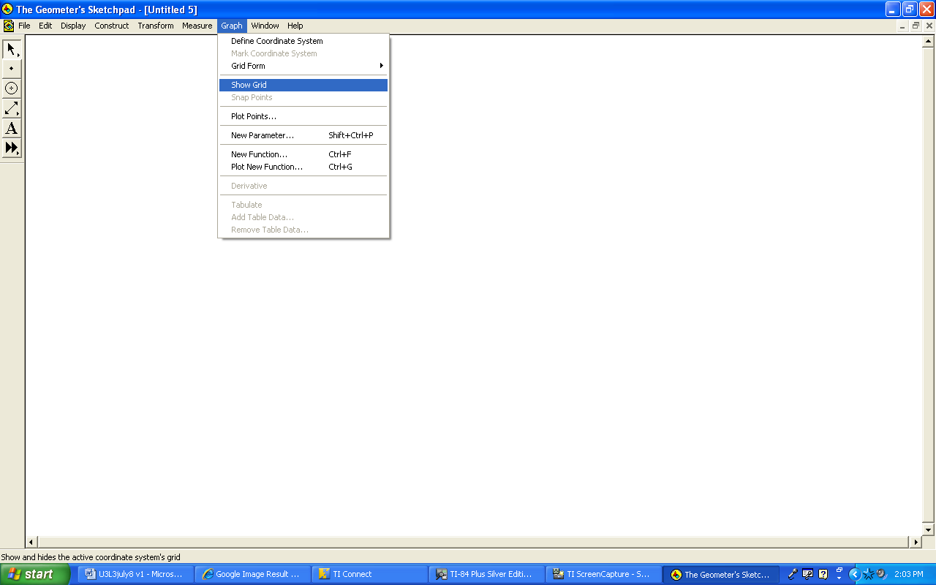
Select the Point Tool. Click anywhere on the y-axis. | 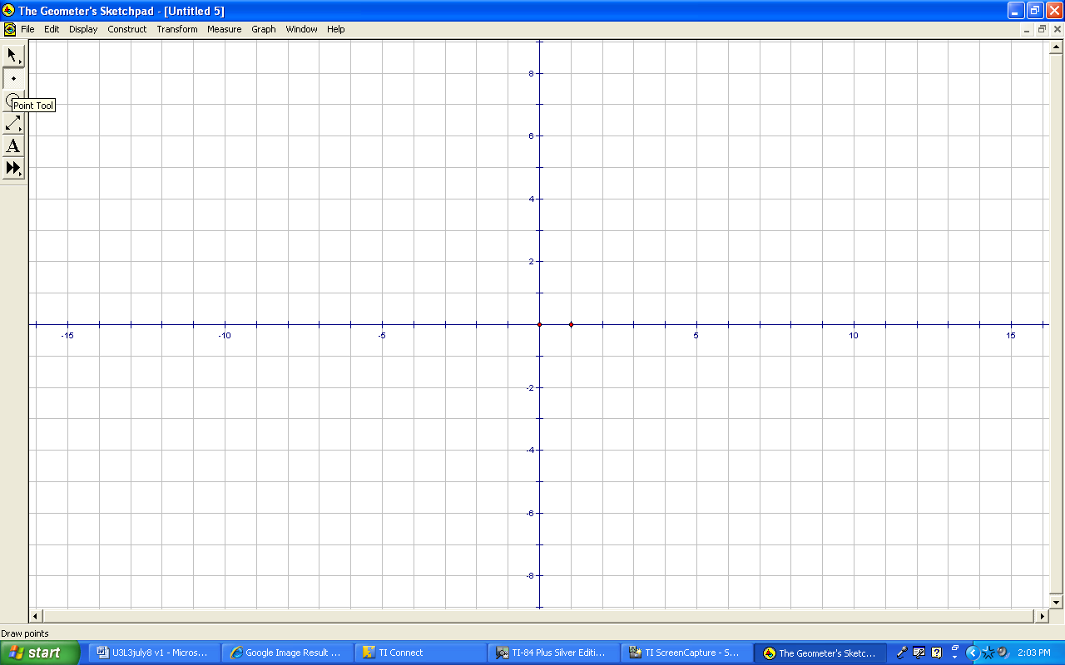
Select Translate from the Transform menu. | 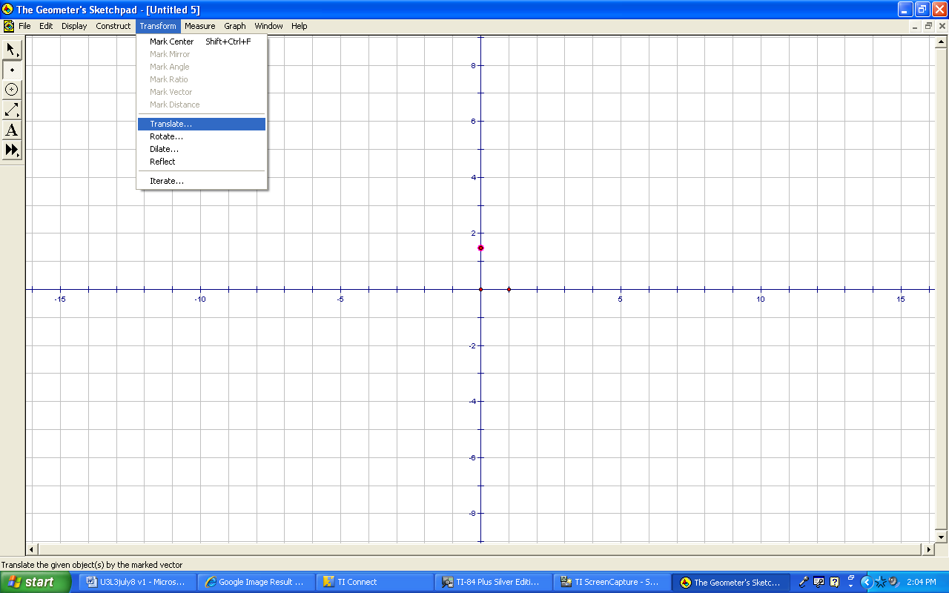
From the Translate pop-up box, click on Rectangular and type in 3 for Horizontal and 2 for Vertical. (It can also be anything you want.) Click Translate. | 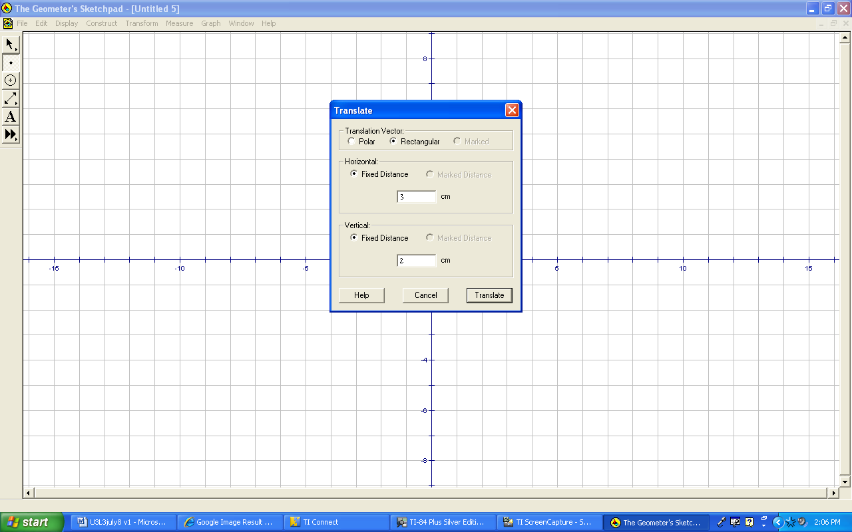
3.3.8 Teacher Instructions for GSP (continued)

A new point now appears. | 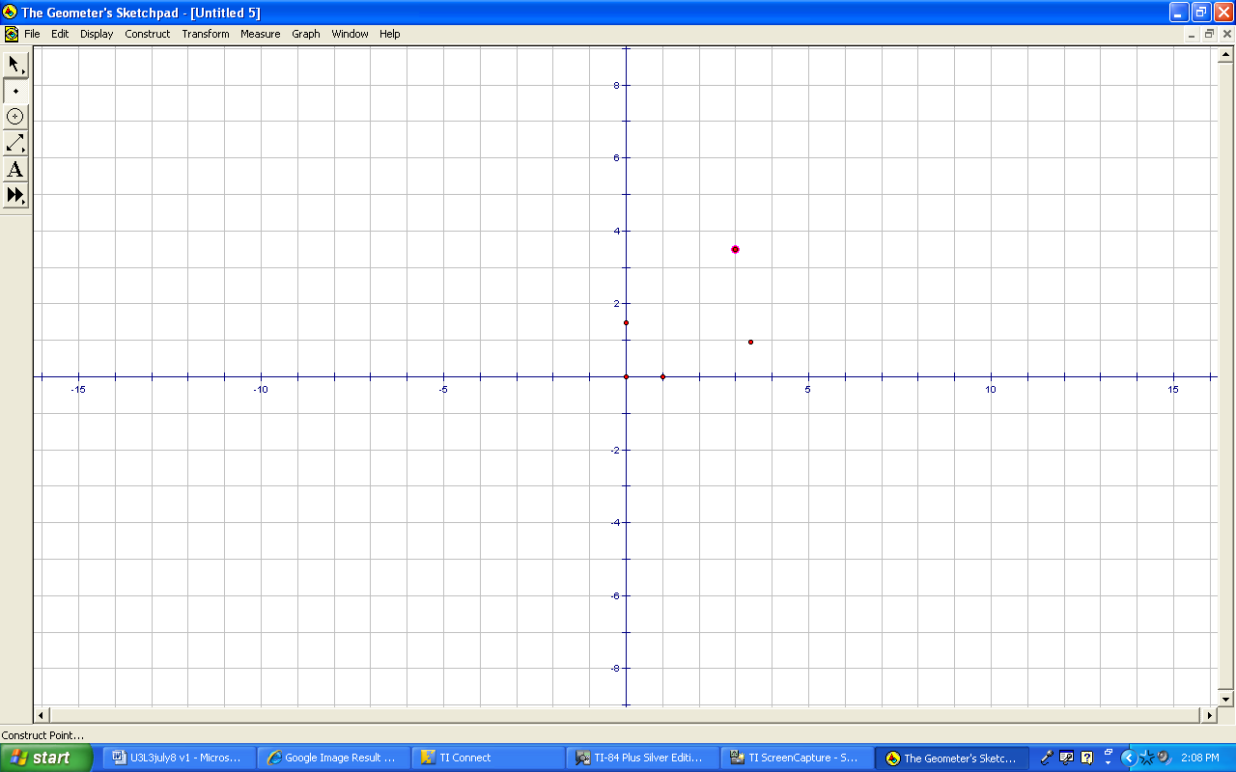
Select the Select Arrow Tool from the left hand side menu. Click anywhere on the white space. Then click on Point A so that Point A is highlighted. | 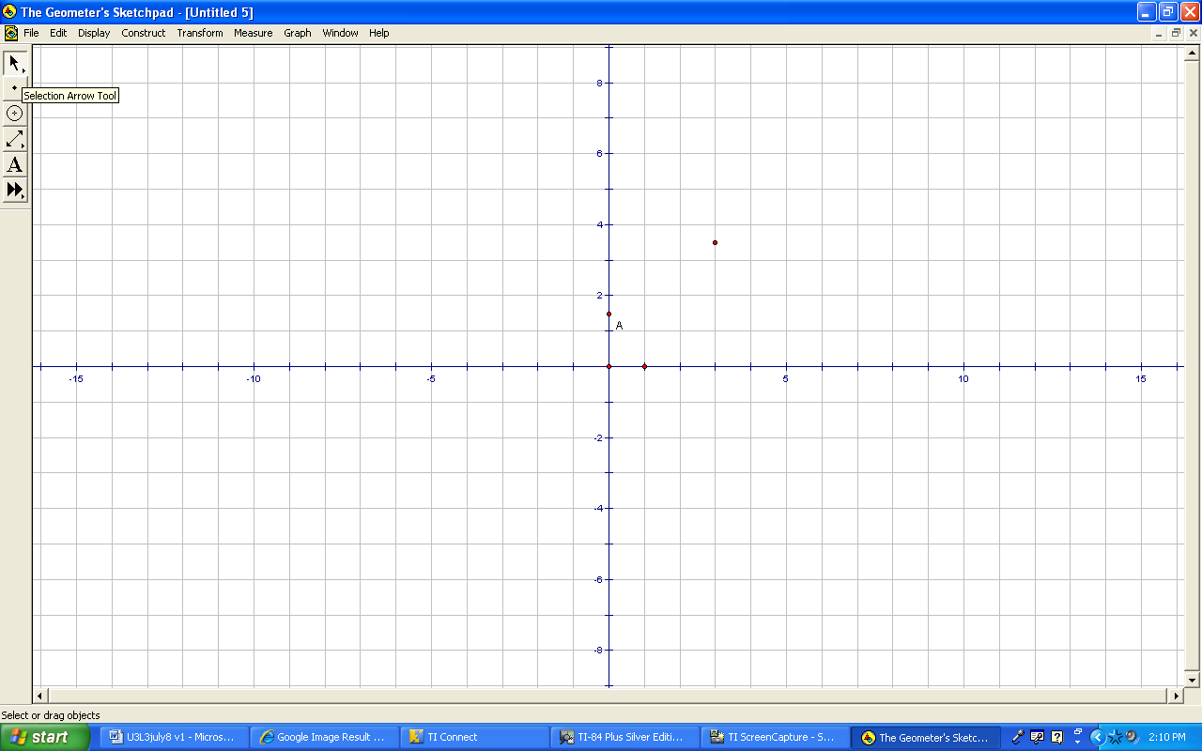
Select Ordinate (y) from the Measure menu. A pink box will appear with the y-intercept position on the y-axis. Click anywhere on the white space. | 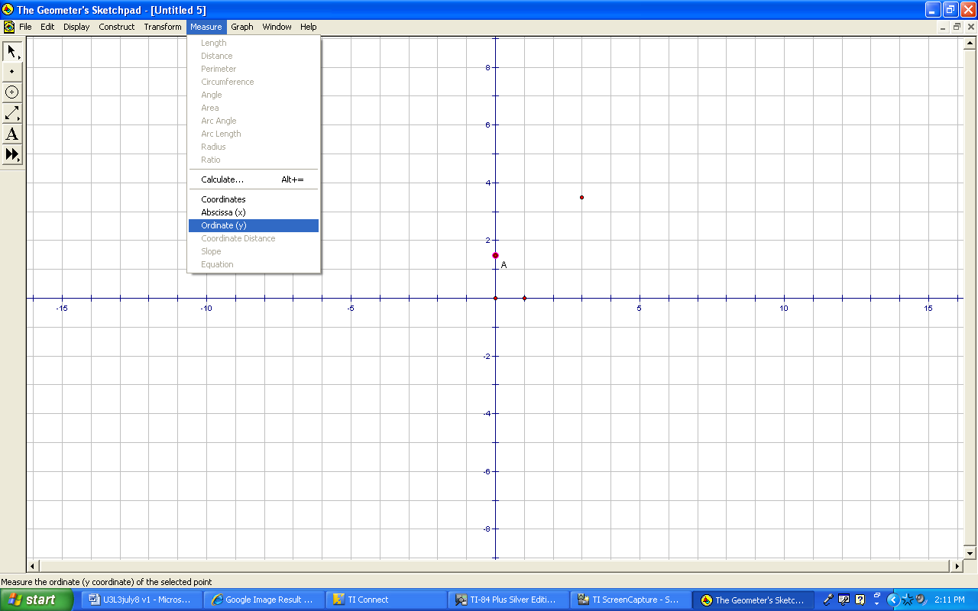
Click and hold the Straightedge Tool from the left hand side menu and select the line with the arrows on both ends. | 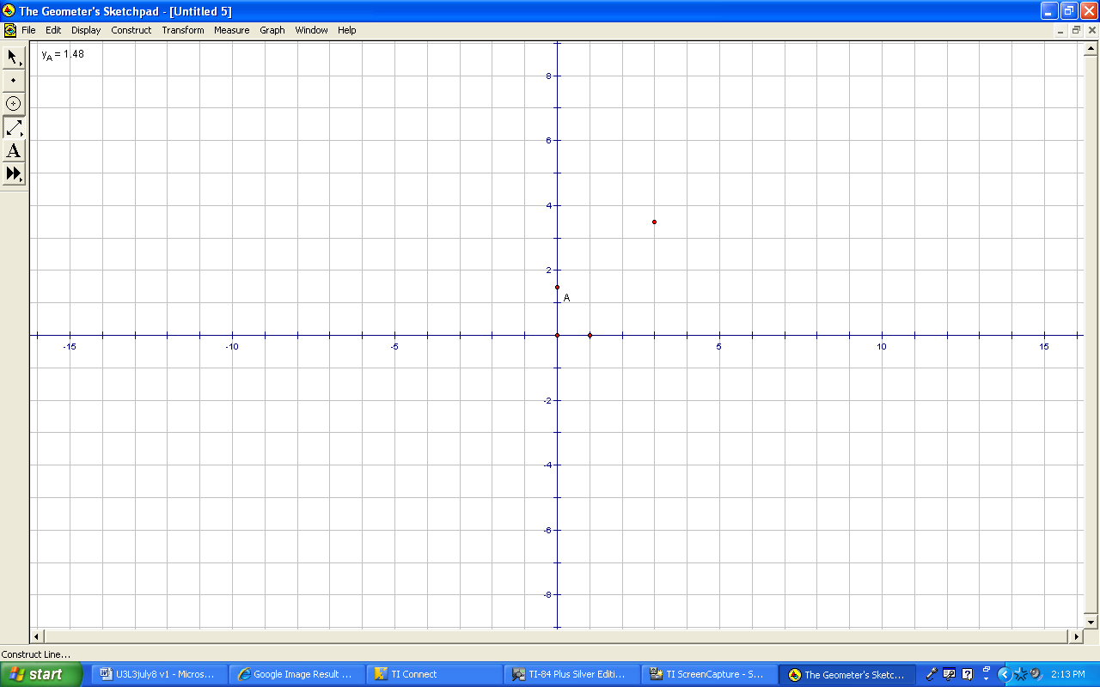
3.3.8 Teacher Instructions for GSP (continued)

Click on Point A and the point that you transformed to create a line. Click on the Select Arrow Tool from the left hand side menu. Click on any white space. Click on the line so that just the line is highlighted. | 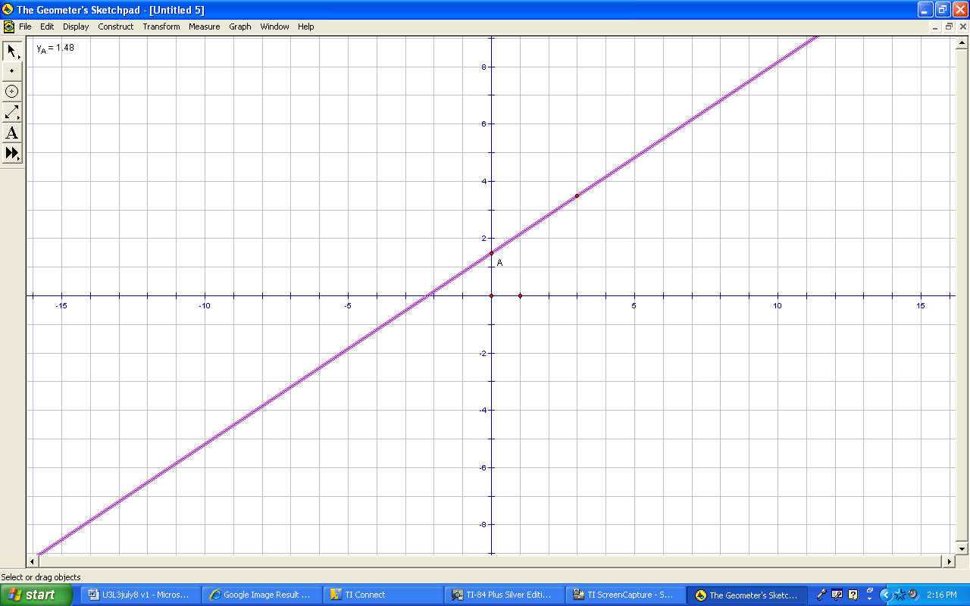
Select Slope from the Measure menu. Click on any white space. | 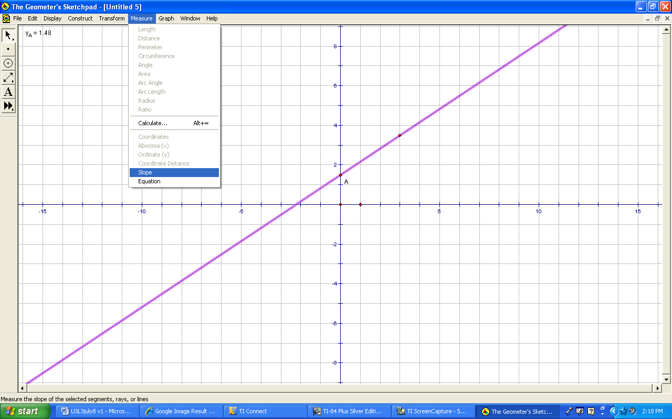
Click on the line so that the line is highlighted. Now you can drag the line up and down and the measurement for the y-ordinate will change accordingly. | 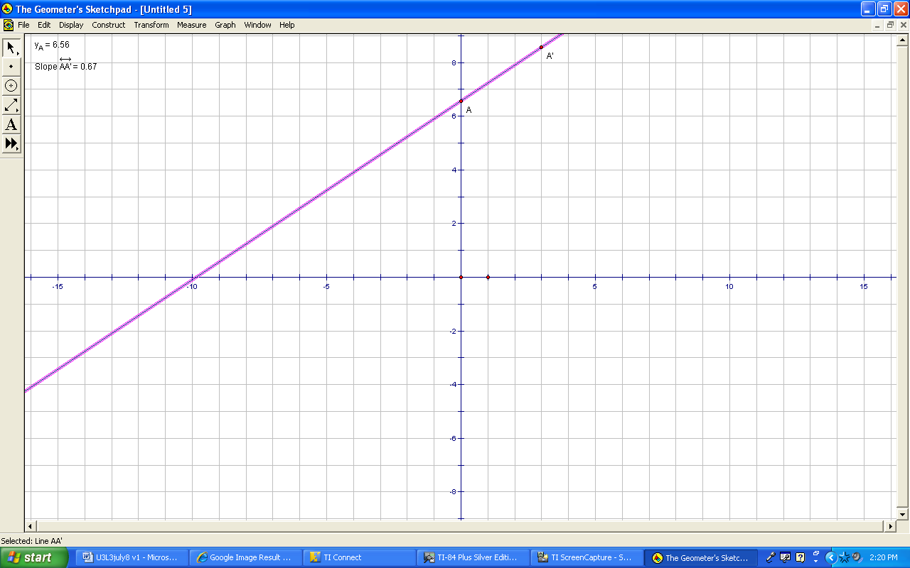
To create parallel lines:  Click on the Point Tool on the left hand side menu and create another point on the y-axis. | 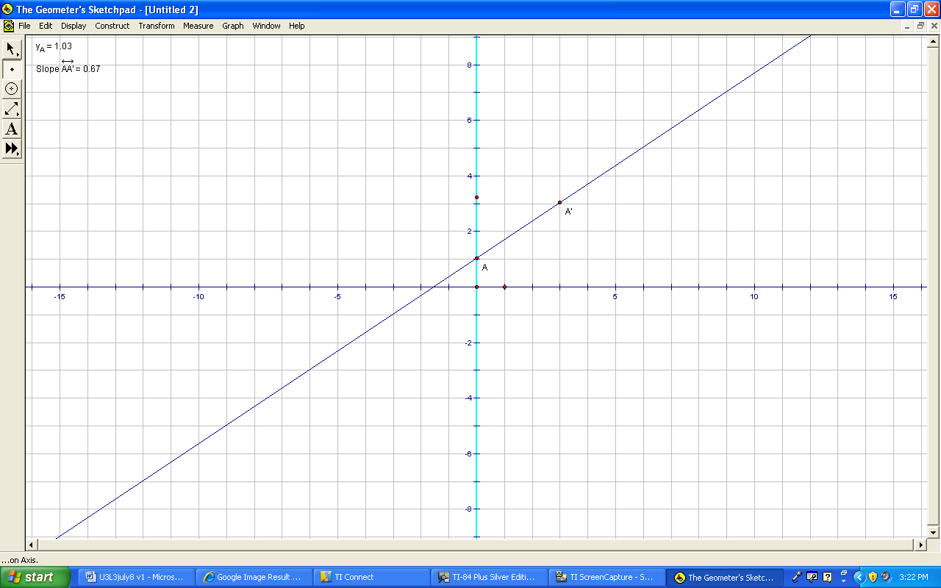
3.3.8 Teacher Instructions for GSP (continued)

Select Translate from the Transform menu. | 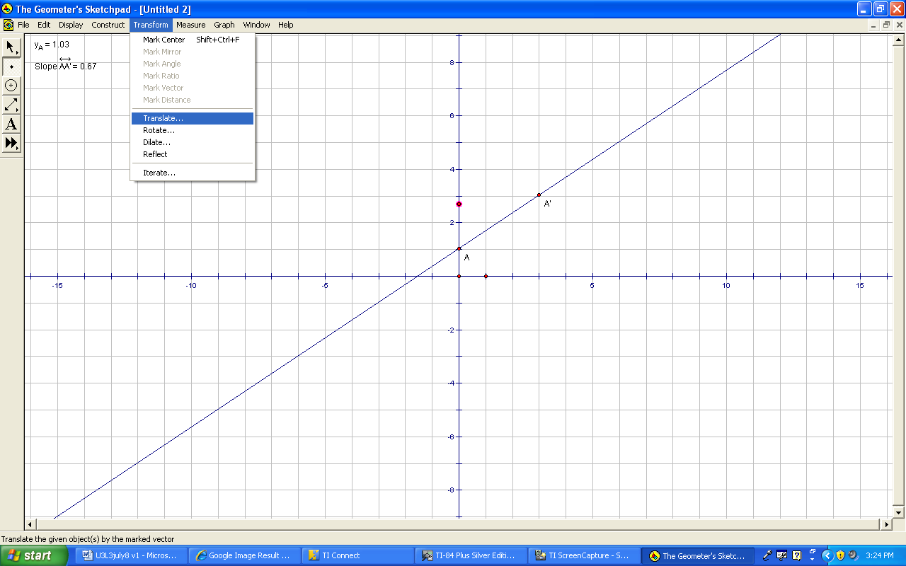
From the pop-up menu, the values that you entered before should be there already. If not, enter them again and make sure you select Rectangular in the middle. Click Translate. | 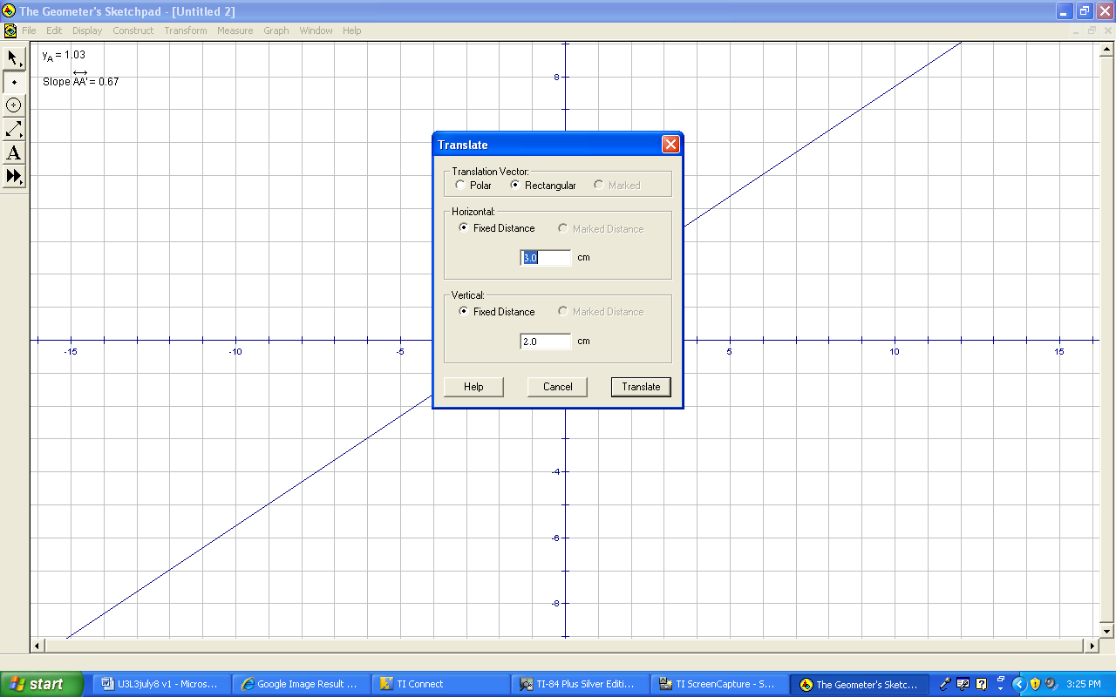
Select the Select Arrow Tool from the left hand side menu. Click on any white space. | 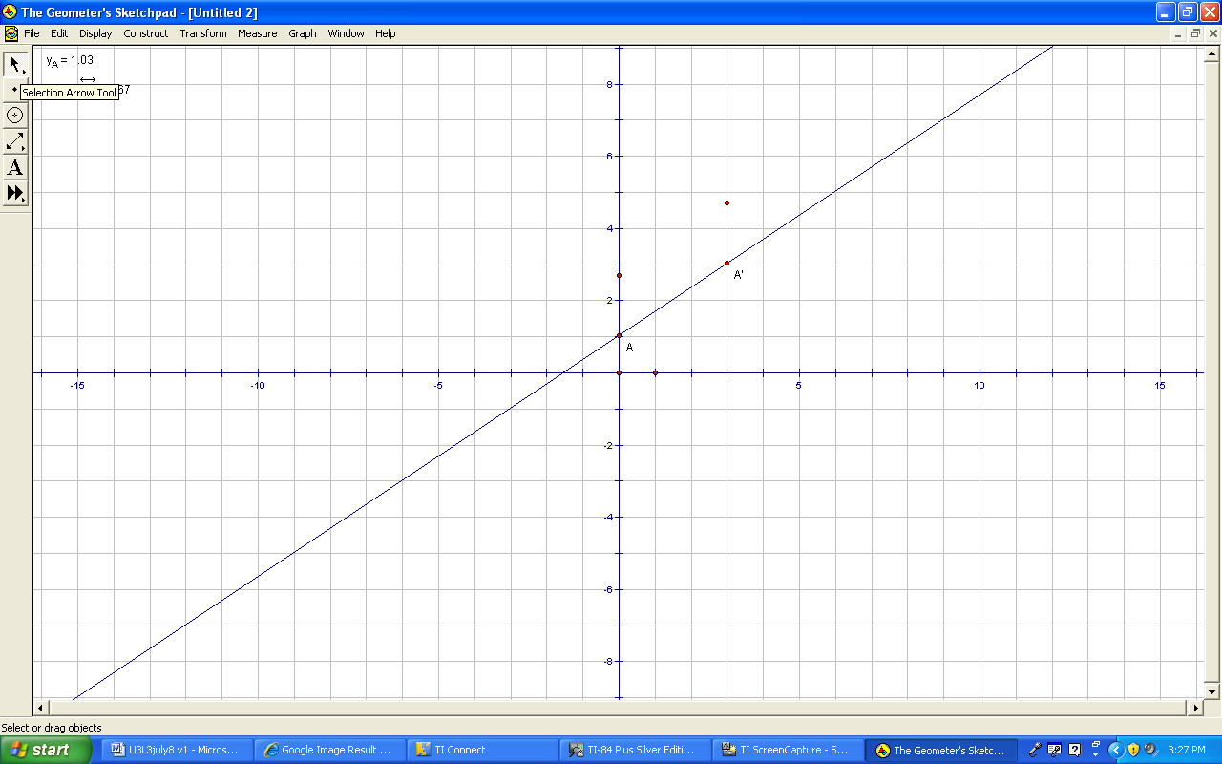
Select the Straightedge Tool on the left hand side and create a line by clicking on the two new points. | 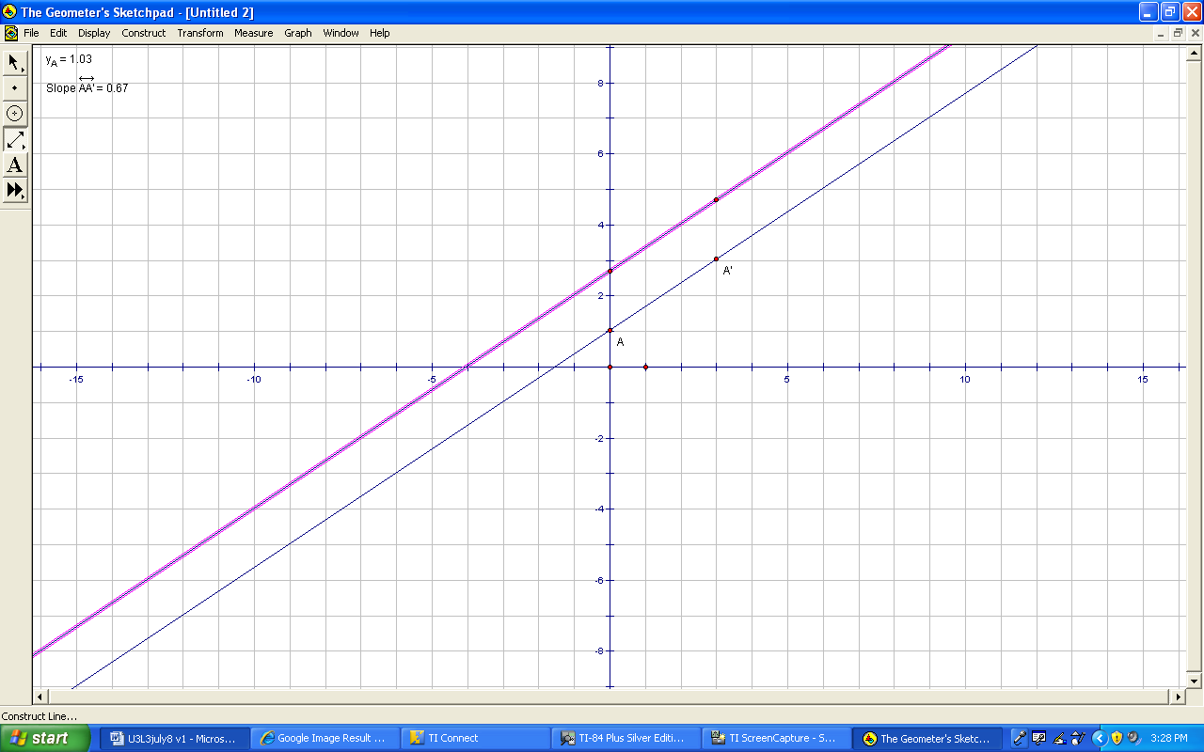
3.3.8 Teacher Instructions for GSP (continued)

Select the Select Arrow Tool from the left hand side menu. Click on any white space. | 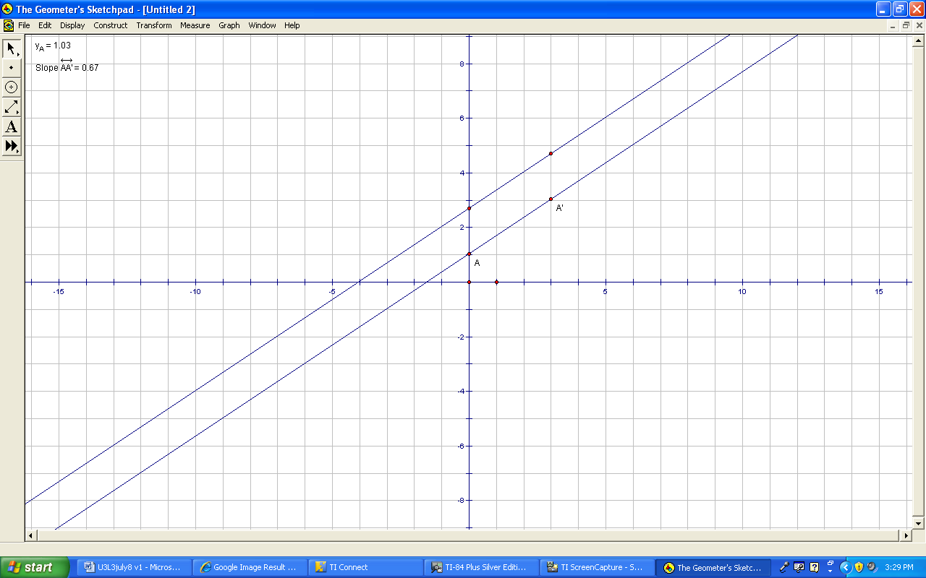
Click on the line to highlight. Select Slope from the Measure menu. | 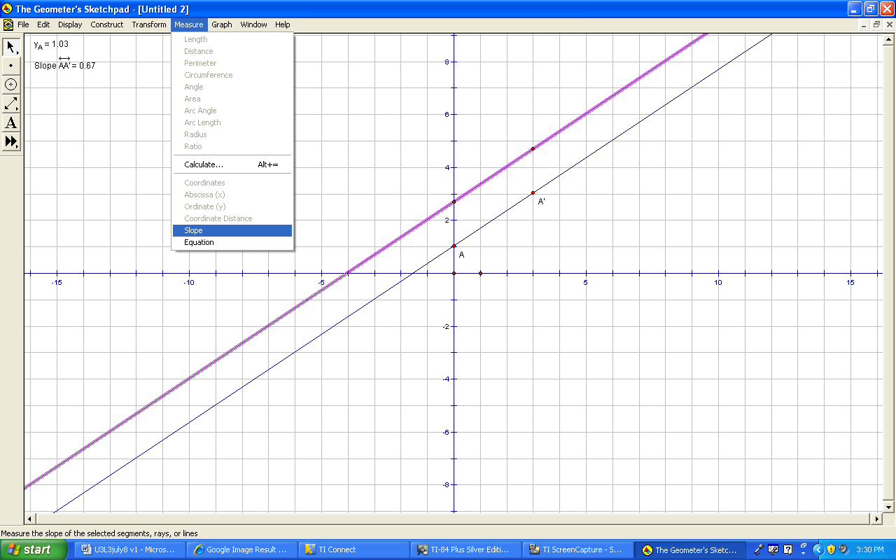
Now you have the slope for both lines. The slopes are the same. Click on any white space. | 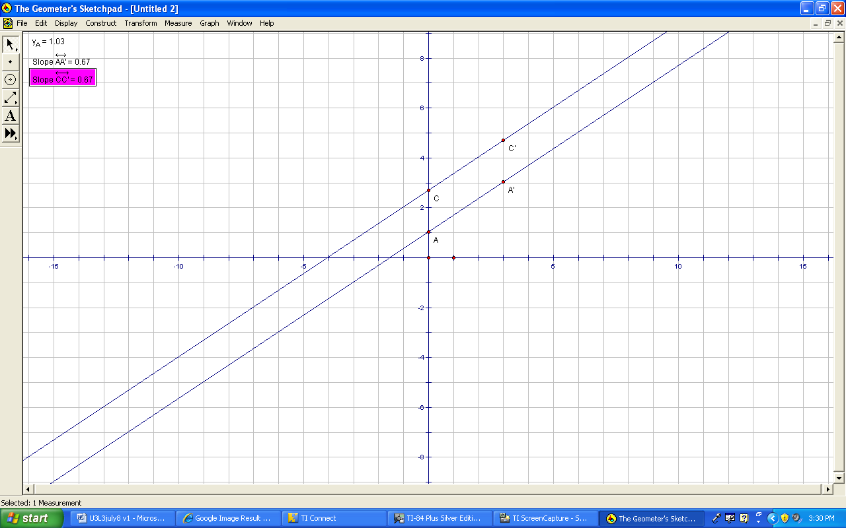
Select the Select Arrow Tool from the left hand side menu. Click on any white space. Click on Point A and click on Point B, so that both points are highlighted. | 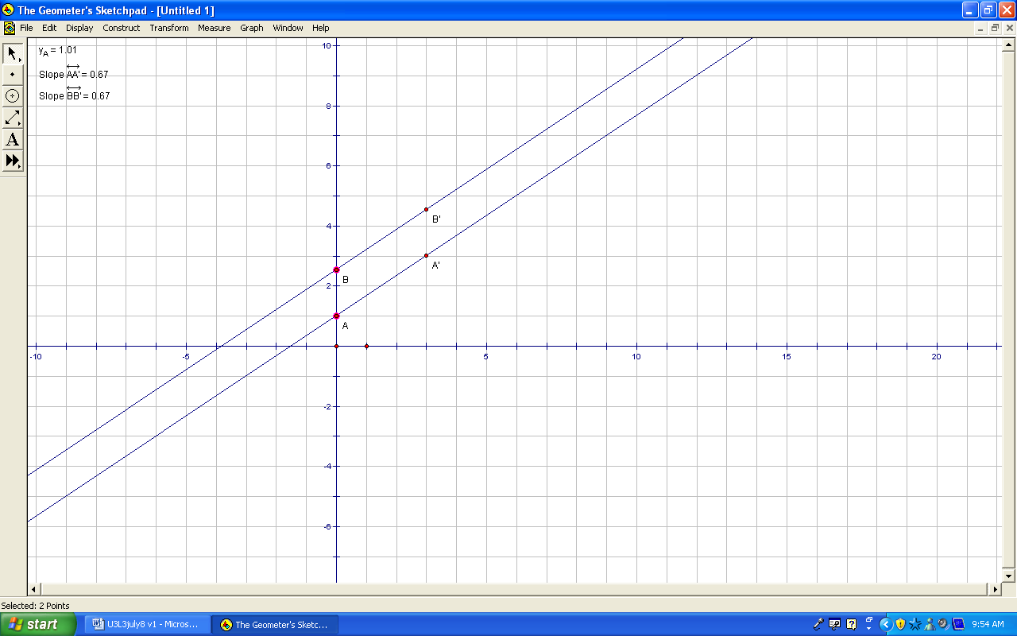
3.3.8 Teacher Instructions for GSP (continued)

Select Coordinate Distance from the Measure menu. Click on any white space. | 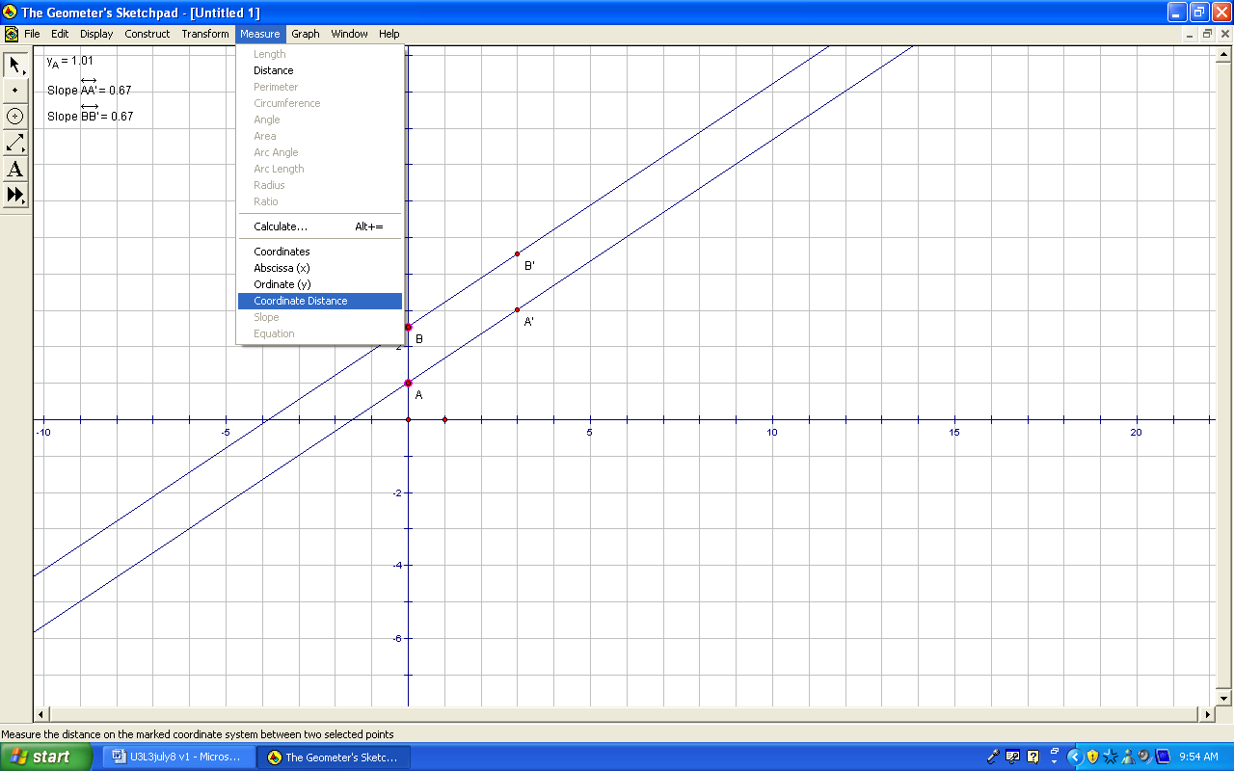
Click on A’ and B’ to highlight the two points. | 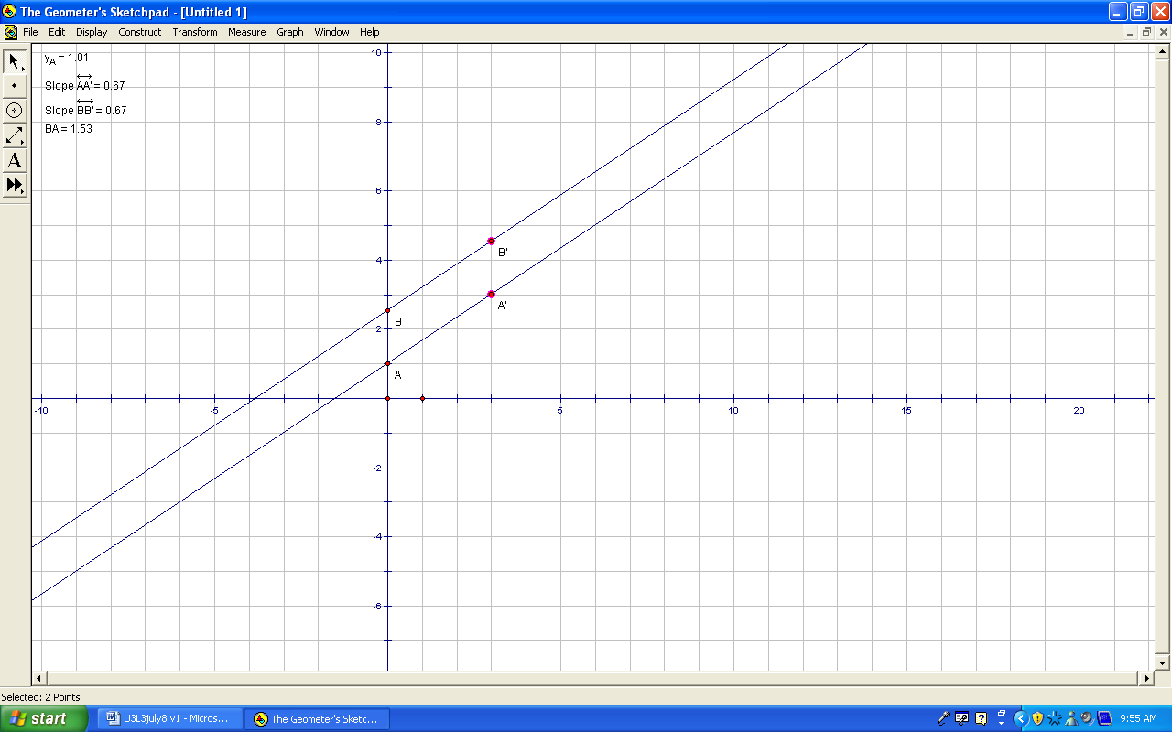
Select Coordinate Distance from the Measure menu. Click on any white space. Because the two coordinate distance are the same, therefore, the two lines must be parallel. | 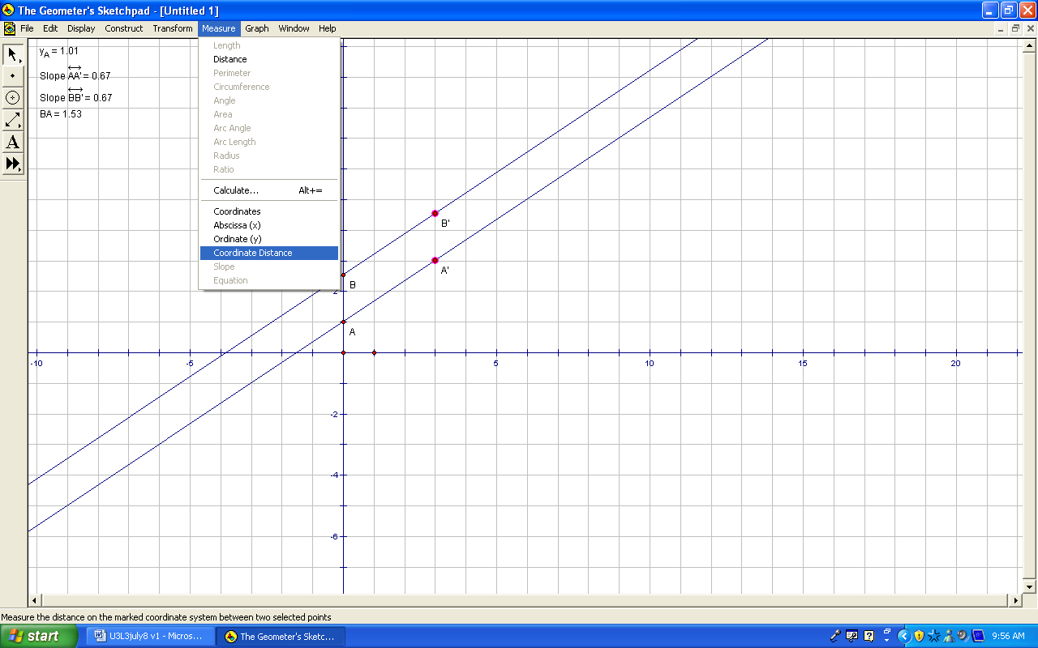

Unit 3 Day 4: Can Graphing Get Any Easier? |  |  |  |  | Grade 10 Applied
Minds On: 15 Min. |  |  | Math Learning Goals  Students will:  - Graph lines by hand using the y-intercept and slope given the equation in the slope y-intercept form |  | Materials  - Graphing Calculators  - BLM 3.4.1 – 3.4.5  - Overhead Projector
Action: 50 Min.
Consolidate/
Debrief: 10 Min
Total = 75 Min.
Assessment
Opportunities
 | Minds On… | Pairs → Exploration  Students will work in heterogeneous pairs to review y = mx + b. Using BLM 3.4.1, have one partner find the slope and the other the y-intercept from a graph. Both partners then come up with an equation for each graph. Students then check their graphs using the graphing calculator. |  |  | Teachers could review each graph with the entire class at the end of Minds On.  BLM 3.4.2 can be used to help out with the calculator key strokes.  At the end of this activity 3.4.3, the teacher can focus on integer value slopes and how to find run value  Teacher may want to copy acetates of BLM 3.4.4 and have students write out their answers.
 | Action! | Pairs→Investigation  Students will work in pairs using BLM 3.4.3. Students will determine how to graph an equation in the form y= mx + b using slope and y-intercept. Students will then write a method for graphing using appropriate mathematical vocabulary.  Mathematical Process Focus: Communication (Students will communicate their answers using appropriate mathematical vocabulary and using various representations e.g. graphs and verbal descriptions.)  Individual→Practice Problems  Students will work individually using BLM 3.4.4.
 | Consolidate Debrief | Class→Graphic Organizer  Students develop a Frayer Model using BLM 3.4.5. Lead a class discussion to create a Frayer Model on the overhead projector to consolidate the process of graphing a line by hand.
Concept Practice |  | Home Activity or Further Classroom Consolidation  Complete BLM 3.4.4.

3.4.1 Graphs, Slopes, Intercepts, Equations and Check

One partner will find the y-intercept of each graph and the other partner will find the slope of each graph. You will both then create an equation that represents the graph. Finally, you will check your equation using the graphing calculator (use BLM 3.4.2 as a reference for your graphing calculator).

GRAPH A
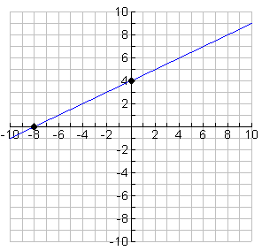 | Partner A  Slope = _____________________
Partner B

y-intercept = _____________________

Join both A and B to create an equation

Equation = __________________________

Check you answer using the graphing calculator.

GRAPH B
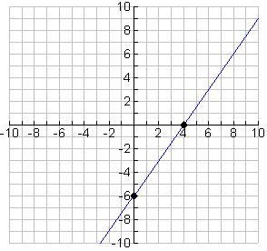 | Partner B  Slope = _____________________
Partner A

y-intercept = _____________________

Join both A and B to create an equation

Equation = __________________________

Check you answer using the graphing calculator.

3.4.1 Graphs, Slopes, Intercepts, Equations and Check (Continued)

GRAPH C
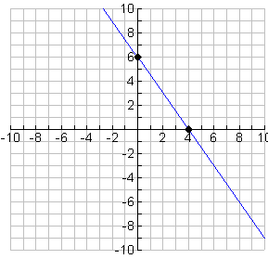 | Partner A  Slope = _____________________
Partner B

y-intercept = _____________________

Join both A and B to create an equation

Equation = __________________________

Check you answer using the graphing calculator.

GRAPH D
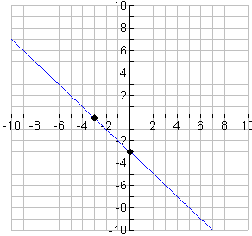 | Partner B  Slope = _____________________
Partner A

y-intercept = _____________________

Join both A and B to create an equation

Equation = __________________________

Check you answer using the graphing calculator.

3.4.2 Graphs, Slopes, Intercepts, Equations and Check: Graphing Calculator Keystrokes

- Prepare your calculator by either running a get-ready program or resetting the graphing calculator.

- Press the  button and set the window setting as shown below:

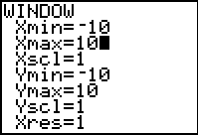

- To enter an equation for graphing press the 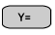

- Enter your equation in Y1. For example, to graph y = -3x - 4 enter:
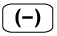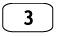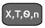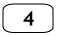
You will see the following on your screen

- To view your graph press the  button. You will see the graph as shown below:

3.4.3 Can Graphing Get Any Easier?

Investigation 1
$$y=\frac{1}{3}x+4$$

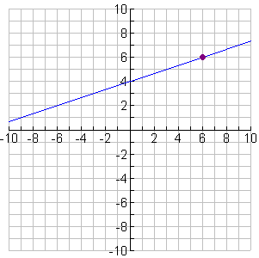
B

- Start at the y-intercept.

- Only moving up (+) or down (-), how many units do you need to reach the same level as point B?

- Only moving right (+), how many units do you have to move your pencil to connect to point B?

- Given the equation for the graph state the slope and the y-intercept

Slope =

y-intercept =

3.4.3 Can Graphing Get Any Easier? (Continued)

Investigation 2

$$y=−\frac{4}{5}x+6$$

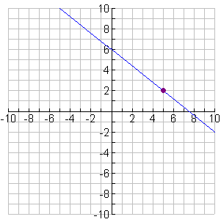
B

- Start at the y-intercept.

- Only moving up (+) or down (-), how many units do you need to reach the same level as point B?

- Only moving right (+), how many units do you have to move your pencil to connect to point B?

- Given the equation for the graph state the slope and the y-intercept

Slope =

y-intercept =

3.4.3 Can Graphing Get Any Easier? (Continued)

Investigation 3

$$y=2x+5$$

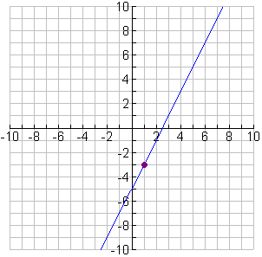
B

- Start at the y-intercept.

- Only moving up (+) or down (-), how many units do you need to reach the same level as point B?

- Only moving right (+), how many units do you have to move your pencil to connect to point B?

- Given the equation for the graph state the slope and the y-intercept

Slope =

y-intercept =
3.4.3 Can Graphing Get Any Easier? (Continued)

Summary

Discuss each question with your partner and both partners write answers.

- Looking at all three investigations, can you relate the values from steps 2 and 3 with the slope or the y-intercept? Explain the relationship.

- Given the following equation:
$$y=\frac{2}{3}x−4$$ | Slope:  y-intercept:

Describe a method to graph this equation by hand using the slope and the y-intercept.

- Using the grid provided below graph the equation$y=\frac{2}{3}x−4$. Write the steps you followed to the right of your graph.
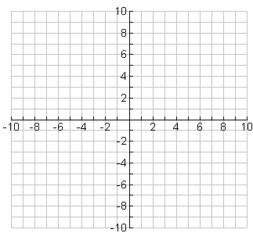
3.4.4 Rising and Running From a Point

Graph the following equations on the grids given below and check your graphs using the graphing calculator.

Note: When you write the slope as a fraction, any negative signs should be placed in the numerator only.

Equation 1 | Equation 2
$$y=\frac{2}{3}x−4$$ | $$y=−\frac{4}{3}x+2$$
Slope =  Rise =  Run =  y-intercept = | Slope =  Rise =  Run =  y-intercept =
Graph: | Graph:
Describe how you graphed the line. | Describe how you graphed the line.

3.4.4 Rising and Running From a Point (Continued)

Graph the following equations on the grids given below and check your graphs using the graphing calculator.

Note: When you write the slope as a fraction, any negative signs should be placed in the numerator only.

Equation 3 | Equation 4
$$y=3x+2$$ | $$y=−x+2$$
Slope =  Rise =  Run =  y-intercept = | Slope =  Rise =  Run =  y-intercept =
Graph: | Graph:
Describe how you graphed the line.

3.4.4 Rising and Running From a Point (Continued)

Graph the following equations on the grids given below and check your graphs using the graphing calculator.

Note: When you write the slope as a fraction, any negative signs should be placed in the numerator only.

Equation 5 | Equation 6
$$y=2x$$ | $$y=3$$
Slope =  Rise =  Run =  y-intercept = | Slope =  Rise =  Run =  y-intercept =
Graph: | Graph:
Describe how you graphed the line. | Describe how you graphed the line.

3.4.5: Graphic Organizer

Definition (in own words) | Rules/Method:
Examples | - Non-examples  Graphing by Hand  Using the Slope and  Y- Intercept

3.4.6: Graphic Organizer – Teacher

Definition (in own words)  Using the slope and y-intercept to graph by hand a linear equation on a grid. | Rules/Method:  - Determine the rise and the run from the slope  - Determine the y-intercept from b  - Plot the y-intercept  - Place pencil on the y-intercept  - Use the rise to move the pencil up (if +’ve) or down (if –‘ve)  - Use the run to move the pencil to the right  - Place a point where the pencil ends  - Create a straight line through the two points extending the line
Examples  $$y=\frac{1}{2}x+3$$  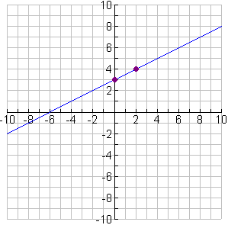 | - Non-examples  Graphing by Hand  Using the Slope and  Y- Intercept  3x + y = 2  x = 2y – 4

Unit 3 Day 5: Temperature Conversions |  |  |  |  | Grade 10 Applied
Minds On: 5 Min. |  |  | Math Learning Goals  Students will:  - Determine a linear equation to convert between Celsius and Fahrenheit temperature  - Solve one variable equations with fractional coefficients in context using CAS and pencil and paper. |  | Materials  - Nspire CAS Handhelds  - BLM 3.5.1 -3.5.3
Action: 60 Min. |  |  |  |  | Materials  - Nspire CAS Handhelds  - BLM 3.5.1 -3.5.3
Consolidate/  Debrief: 10 Min |  |  |  |  | Materials  - Nspire CAS Handhelds  - BLM 3.5.1 -3.5.3
Total = 75 Min. |  |  |  |  | Materials  - Nspire CAS Handhelds  - BLM 3.5.1 -3.5.3
Assessment
Opportunities
 | Minds On… | Whole Class→Discussion  Lead a class discussion to activate prior knowledge about Celsius and Fahrenheit temperature by having students share what they know such as:  - The USA is the only country that still uses Fahrenheit  - Celsius degree are larger than Fahrenheit degrees  - Equivalent temperatures (0°C=32°F, 20°C=68°F,100°C=212°F) |  |  | If you do not have access to Nspire CAS you can use TI-89 or TI-92 graphing calculators.  For information on using CAS with these devices visit  http://education.ti.com/  If you have no access to CAS devices you will need to adapt BLM3.5.2 so pencil and paper is the only method used.
 | Action! | Whole Class→Guided Demonstration  Distribute CAS Introduction (BLM 3.5.1) and Npsire CAS handhelds. Students work in pairs on BLM 3.5.1 to demonstrate how to use Nspire CAS handheld units to solve and check one variable equations  Pairs→A coaches B, Investigation  Assign heterogeneous pairs. Distribute investigation on BLM 3.5.2. Using Nspire CAS handhelds, students work in pairs to determine the linear equation used to convert between Celsius and Fahrenheit and use it to convert between the temperature scales by solving one variable equations using CAS and pencil and paper. A coaches B for the conversions in the activity. Switch roles after each conversion.  Learning Skills/Observation: During guided discovery and investigation observe teamwork and comprehension and intervene where needed.
 | Consolidate Debrief | Whole Class→Discussion  Lead a class discussion to share strategies on solving equations with fractional coefficients using pencil and paper. Students record strategies in their notes.
Application  Concept Practice |  | Home Activity or Further Classroom Consolidation  Students practice solving one variable equations with fractional coefficients using pencil and paper by completing BLM 3.5.3. Assign other practice questions as necessary.

3.5.1: Nspire CAS Handheld Manual

Getting Started

When you turn on the handheld, press c6.

You will be asked whether you want to save the document. Select No. To do this, use the large circular “navpad” to move to the right, then press the ·button.

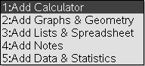
Next select 1:Add Calculator. To do this, press the 1 button.

You are now ready to use CAS on the handheld.

Some Helpful Shortcuts
If you make a mistake at any point that you want to undo, press / Z.
If you undo something that you want back again, press / Y.

How to Solve for a One Variable Equation: Example One
Say that you wish to solve the equation 3x + 2 = 14
To do this, first be certain that you are on a Calculator page. If you need help with this, see the Getting Started section above.
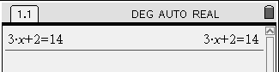First type in the equation that you want to solve. Use the number pad and the green letter keys; the operations ( $¸$, $´$, -, + ) are located on the right, and the equals sign ( = ) is in the top-left corner of the keypad. When you have typed in the equation, press the · key, found in the bottom-right corner.
The top of your screen will look something like this:

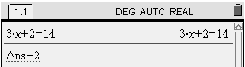Now decide how you would start in solving for x.
Perhaps you’ve decided that subtracting 2 from both sides of the equation is a good start. Wonderful! To do this, immediately press - 2. Notice that the handheld automatically inserts Ans . What is this?
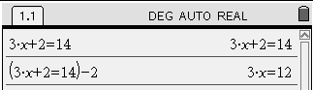Ans stands for the last answer you found. If you now press the · key, the handheld will subtract 2 from the left side and the right side of 3x + 2 = 14. You will see this result:
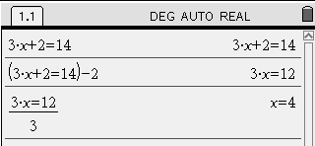Continue solving the equation. You probably see that to finally isolate the x variable, it is necessary to divide the equation by 3 on both sides. Again, just start typing the operation you want to perform. Press p 3. The handheld will insert Ans for you. Press ·• to calculate the result.
As you can see, the handheld reports that x=4.

3.5.1: Nspire CAS Handheld Manual (Continued)

How to Solve for a Variable: Example Two
Say that you wish to solve the equation 6x - 5 = 8 for the variable y.
To do this, first be certain that you are on a Calculator page. If you need help with this, see the Getting Started section above.
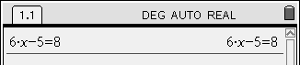First type in the equation that you want to solve. Use the number pad and the green letter keys; the operations ( $¸$, $´$, -, + ) are located on the right, and the equals sign ( = ) is in the top-left corner of the keypad. When you have typed in the equation, press the · key, found in the bottom-right corner.
The top of your screen will look something like this:
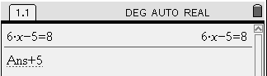
Now decide how you would start solving for x.
Perhaps you’ve decided that adding 5 to both sides of the equation is a good start. Wonderful! To do this, immediately press + 5. Notice that the handheld automatically inserts Ans. What is this?
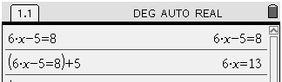Ans stands for the last answer you found. If you now press the · key, the handheld will add 5 to the left side and the right side of 6x - 5 = 8. You will see this result:
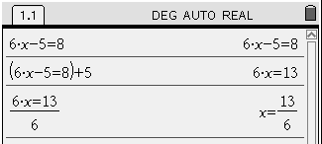Continue solving the equation. You probably see that to finally isolate the x variable, it is necessary to divide the equation by 6 on both sides. Again, just start typing the operation you want to perform. Press p 6. The handheld will insert Ans for you. Press · to calculate the result.
As you can see, the handheld reports that
$x=\frac{\text{13}}{6}$.
Is this the result you expected?
To convert this result to its decimal equivalent press / ·

Now, try to solve the following equations on your own. Remember to start a new calculator screen for each one.

3x – 4 = -7
7 + 2x = 4

-2x + 8 = 3x + 3

3.5.1: Nspire CAS Handheld Manual (Continued)

How to Check a Solution to a One Variable Equation
Say that you have solved the following equation: 6x - 5 = 8
and you believe the solution is $x=\frac{\text{13}}{6}$
This would be tedious to check by pencil and paper, but it is quick to check with the handheld.
Here is how to do it. First be certain that you are on a Calculator page. If you need help with this, see the Getting Started section from earlier in this manual.
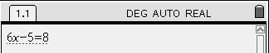Here is how to do it:
First type in the equation but do not press ·. The screen looks like:
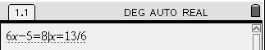
Next, continue typing by pressing the grey key with the vertical line * (in the top row). This symbol means “such that”. Continue typing x=13 p 6. The screen looks like:

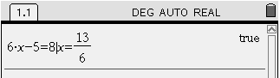When you press · the handheld says true to indicate that the solution is correct. If the solution is not correct the handheld will return false.

Now, check your solutions to the three equations you solved on the previous page.

If there are any notes you want to make to help you remember how to solve and check equations use the box below.

3.5.2: Temperature Conversions - Investigation

Goal: With a partner you will investigate how to solve one variable equations that have fractional coefficients using CAS and pencil and paper.

Nethead is planning to go to visit Wingman in Detroit. Wingman says that the temperature is 23º Fahrenheit. Nethead wants to know if he needs to packs warm clothing for his trip. How many degrees Celsius is 23º Fahrenheit?
We first need a formula that converts Celsius to Fahrenheit. Here’s some info to help.
Temperature in Celsius (x) | Temperature in Fahrenheit (y)
0 | 32
20 | 68

1. What is the y-intercept? _____________

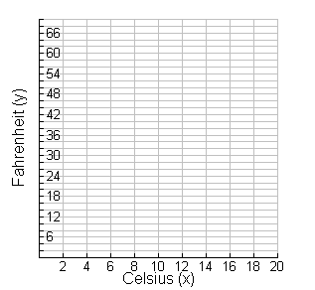2. If we write the information as points (0, 32) and (20, 68), plot the two points and find the slope using a rate triangle.

Slope = $\frac{\text{rise}}{\text{run}}$ =

(Write the slope as a fraction in reduced form.)

3. Now that we know the y-intercept and slope, state the equation relating Celsius (x) to Fahrenheit (y).

4. Using your equation convert the following two temperatures in degrees Celsius to degrees Fahrenheit.
a) 10º | b) 30º

3.5.2: Temperature Conversions - Investigation (Continued)

Lets help Nethead now: How many degrees Celsius is it if its 23º Fahrenheit?
(Hint: Substitute 23 for y and solve the equation for x using the Nspire CAS handheld.)

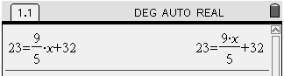When you enter the equation it will look like:

First subtract 32 from both sides

Remember that $\frac{9x}{5}$ means x multiplied by 9 and divided by 5. So, you have to do the opposite of each of the two operations to solve for x.

Your screen will look like:

So 23° Fahrenheit is -5° Celsius.

If we could get rid of the fractions in the equation first you could solve the equation without using CAS. Enter the original equation $\text{23}=\frac{9x}{5}+\text{32}$again and multiply by 5, then subtract and divide to solve. Your solution looks like:

Comparing the two solutions you can see the second one could be done without CAS.

5. Convert the following two temperatures in degrees Fahrenheit to degrees Celsius by solving the equation by pencil and paper first and then checking your solution using CAS.
a) 5º | b) 83º | c) -10º

3.5.3: Temperature Conversions - Practice

1. Solve the following equations using pencil and paper.

a) $\frac{5x}{3}−4=6$ | b) | c)  Hint: Multiply each term by the common denominator

2. Typing Speed: The formula for calculating typing speed is
where
s is the speed
w is the number of words
t is the time in minutes
e is the number of errors

a) Nethead types 250 words in 15 minutes with 9 errors. Calculate his typing speed.

b) Wingman types 500 words in 5 minutes and has a typing speed of 72 words per minute. How many errors did he make?

Unit 3 Day 6: Can You Stop the Fire? |  |  |  |  | Grade 10 Applied
Minds On: 10 Min. |  |  | Math Learning Goals  Students will:  - Create a scatter plot and line of best fit from collected data.  - Determine the equation of the line of best fit by hand.  - Verify the scatter plot and equation of line of best fit using technology  - Write linear equations for relationships in context from given information.  - Create contexts for given linear relations in slope y-intercept form. |  | Materials  - Graphing Calculators  - Linking Cubes  - Overhead Projector  - BLM 3.6.1 – 3.6.6
Action: 60 Min.
Consolidate/
Debrief: 5 Min
Total = 75 Min.
Assessment
Opportunities
 | Minds On… | Groups → Matching Models  Students are given cards from BLM 3.6.1. Each student will receive either a card containing a graphical model, algebraic model, a slope or a y-intercept. Once all the cards are distributed, students are to find matching cards for the same linear relation. Form groups of 3.  Mathematical Process Focus – Representing (Students will represent a linear relationship as a graph, equation and word problem.) |  |  | Teacher should have BLM 3.6.1 cut out before class. Make sure the cards are mixed up before handing the cards out.  Graphing calculators can be used for students to verify their equations. If time runs out, this can be continued for homework  Literacy Strategy:  During Consolidation use the Four Corners strategy to review and consolidate.  (Think Literacy: Cross-curricular Strategies Grades 10-12, p 106)
 | Action! | Group→Investigation  Students in groups from the Minds On work on BLM 3.6.2 Can You Stop The Fire? Discuss the context with the students to be sure they understand the problem. Students create the linear models by hand and verify using regression on the graphing calculator. BLM 3.6.3 contains the instructions for students to perform regression and to graph data on the graphing calculator.  Mathematical Process Focus: Representing (Students will represent applications of linear relations, graphically and algebraically using technology)  Individual→Practice Problems  Students will solve the problems individually on BLM 3.6.4 using linking cubes, graphs and statements.
 | Consolidate Debrief | Whole Class→Four Corners Activity  Make four large signs with the numbers 1 to 4 on them. Place them in the four corners of the classroom. Make an overhead of BLM 3.6.5.  Based on the algebraic model given, students decide on an answer and move to the appropriate corner. Students should counsel each other so everyone moves to the appropriate corner. Repeat for the last model.
Application |  | Home Activity or Further Classroom Consolidation  Complete practice problems on BLM 3.6.6.

3.6.1 Can Three Things Be Really The Same?


Group 1
Models | Student Cards Below
Graphical Model | 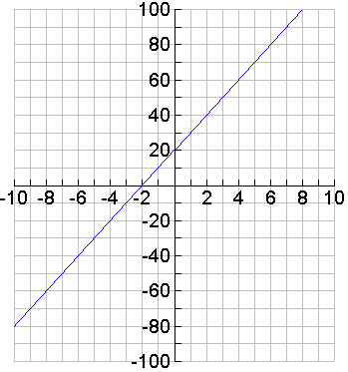
Algebraic Model | $$y=\text{10}x+\text{20}$$
Real-Context Model | You initially have 20 songs in your iPod and you can download 10 songs per hour.
3.6.1 Can Three Things Be Really The Same? (Continued)


Group 2
Models | Student Cards Below
Graphical Model | 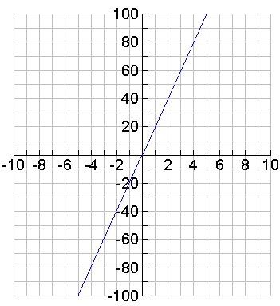
Algebraic Model | $$y=\text{20}x$$
Real-Context Model | You are capable of scoring 20 points every game in basketball.

3.6.1 Can Three Things Be Really The Same? (Continued)


Group 3
Models | Student Cards Below
Graphical Model | 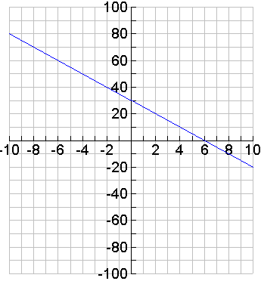
Algebraic Model | $$y=−\text{10}x+\text{20}$$
Real-Context Model | A football is initially thrown from a cliff at a height of 20 m. The ball drops 10 m every second.

3.6.1 Can Three Things Be Really The Same? (Continued)


Group 4
Models | Student Cards Below
Graphical Model | 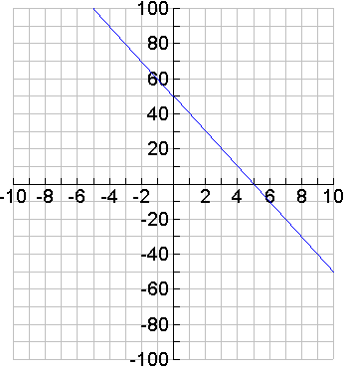
Algebraic Model | $$y=−\text{10}x+\text{50}$$
Real-Context Model | You are given 50 minutes initially cell phone airtime free each month. You use 10 minutes each day.

3.6.1 Can Three Things Be Really The Same? (Continued)


Group 5
Models | Student Cards Below
Graphical Model | 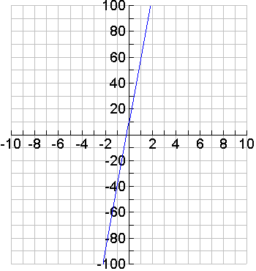
Algebraic Model | $$y=\text{50}x+\text{10}$$
Real-Context Model | A person is able to walk 50 metres per minute. The person starts 10 metres from home.

3.6.1 Can Three Things Be Really The Same? (Continued)


Group 6
Models | Student Cards Below
Graphical Model | 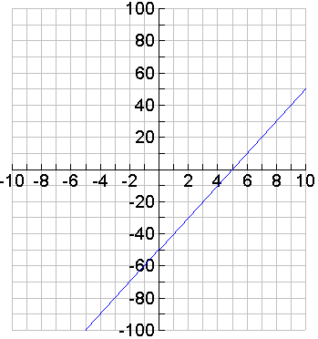
Algebraic Model | $$y=\text{10}x−\text{50}$$
Real-Context Model | A swimmer is 50 m below sea level. She swims constantly at a rate of 10 metres per minute.

3.6.2 Can You Stop The Fire?

Problem:
You work for the Ministry of Natural Resources as a Fire Fighting supervisor. You arrive in Dryden Ontario where you find two fires burning.
- The first fire has just started along 3 km of shoreline beside a lake and is moving east at a rate of 2 km/hr.
- The second fire is also rectangular in shape and is being extinguished to the west by fire fighters at a rate of 1 km/hr.
- Both fires can only change east and west. They will not get wider or narrower.

The picture below shows how the fires looked at the moment you arrived.
Note: Each square = 1 km²

FIRE 2: Direction of Receding Fire at 1 km/hr


Lake

FIRE 1: Direction of Spreading Fire at 2 km/hr

3.6.2 Can You Stop The Fire? (Continued)

Questions:

- Use the linking cubes to create models that represent the area of both fires at 0, 1, 2 and 3 hours. Each cube represents 1 km². Use different colours for the “contained fire” model and the “spreading fire” model.
- Complete the tables below.
FIRE 2: The Receding Fire
Time | h (km)  (Height) | w (km)  (Width) | A (km²)  (Area)
0 | 4 | 7
1 | 4
2
3
4
5
FIRE 1: The Spreading Fire
Time | h (km)  (Height) | w (km)  (Width) | A (km²)  (Area)
0 | 3 | 1
1 | 3
2
3
4
5

- What variable is the x-variable (independent) (Circle one): Time or Area
- What variable is the y-variable (dependent) (Circle one): Time or Area
- What is the y-intercept (initial value) of both fires:

  - y-intercept of Fire 1:

  - y-intercept of Fire 2:

- For both sets of data, graph the time vs. the Area of the fires on the grid on the next page and draw lines of best fit for each set of data. Use different colours for each line. Label both axes and each line.

3.6.2 Can You Stop The Fire? (Continued)

- Using the graphs, or the tables, determine the slope (rate of change) of both fires.

  - Slope of Fire 1:

  - Slope of Fire 2:

- Using the graphs, what is the area of the fires at 6 hours?

  - Area of Fire 1:

  - Area of Fire 2:

3.6.2 Can You Stop The Fire? (Continued)

- Using the values of the slopes and y-intercepts, write an equation of both fires in the form of y = mx + b:

  - Equation of Fire 1:

  - Equation of Fire 2:

- Using the regression function of the graphing calculator, check to see if your equations are correct. 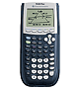 (See 3.6.3 for details.)
- Using the graphing calculator, check to see if your graphs are correct by graphing both equations. (See 3.6.3 for details.)
- Using the equations, find the areas of both fires at 6 hours. Compare your answers to the answers from question 9.
Show work for Fire 1

Area of Fire 1 at 6 hours:
Show work for Fire 2

Area of Fire 1 at 6 hours:
- Looking at both graphs, do the lines ever meet? (Circle one) Yes or No
- If the lines meet, at what time and area does it occur?
  - Time:
  - Area of Fire:

- Explain the significance of this point in this context.

3.6.3 Can The Graphing Calculator Stop the Fire?

Determining the Equation of a Line
- Prepare your calculator by either running a get-ready program or resetting the graphing calculator.
- Enter the data into the list of the calculator be pressing 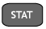 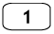. Enter the time for into L1 and the area of the fire into L2

- Once all the data has been entered the calculator will perform linear regression to determine the equation of the line of best fit.
- To determine the equation for the line of best fit press 
- Press 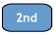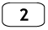 to state the two lists to use. Your screen will look like:
- Now press  to generate the equation. Your screen will show results similar but with different values as below:
Note: a represents the slope.

- In this case your equation would be: y = 1x + 5 or y = x + 5

3.6.3 Can The Graphing Calculator Stop the Fire? (Continued)

Determining the Equation of a Line
- To view the graph of the data and graph you must first enter the equation of the line in Y1 by pressing
- Next enter the equation from above into Y1: 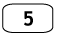 for y = x + 5

- Change the window settings as illustrated below be pressing
- Now to view the graph press

- Compare with the graph you made earlier by hand. If they are different check for errors.

3.6.4 Modelling Algebraically Problems

Piggy Bank Math  Little Johnny has three dollars to put into his brand new piggy bank. He will deposit his entire two-dollar per week allowance into his piggy bank.  - Create a table that shows how much little Johnny will have over the first three weeks.  - Create an equation in the form of y = mx + b from the data above.  - He wants to buy a pet fish that he will name “Ernie” by Christmas, that is, in 9 weeks. Will he have enough money to buy Ernie if he costs $23  - Little Johnny is also considering saving up for a new bike that costs $127. If he does not buy the fish, how long will it take until he has saved up enough to buy the bike? | Patterns in Area  Consider the following patterns created with unit cubes  - Fill in the picture of 4th shape.  - Fill in the Total Area Column  - Create an equation in the form of y = mx + b from the data above.  - Using your equation, what will the area of 12th figure be? Show your work.  - How many shapes would you have to build to have 139 cubes? Explain.
  Weeks | Balance
  0 (today) | 3
  1
  2
  3
  Shape # | Picture | Total Area
  1
  2
  3
  4

3.6.4 Modelling Algebraically Problems (Continued)

The Mechanic Problem  A mechanic earns $25 per hour  - The graph below illustrates hours worked versus earnings.  - Label the axis in the graph above.  - Create an equation in the form of y = mx + b from the data above.  - How much will the mechanic earn after 40 hours  - How many hours must the mechanic work if she earns $1240? | Patterns in Area  Consider the following patterns created with unit cubes  - Build the first, second, third and fourth shapes with the cubes. Fill in the picture of the 4th shape.  - Fill in the Total Area Column  - Create an equation in the form of y = mx + b from the data above.  - What will the area of 7th figure be? Show your work.  - Can you build the 8th figure? Explain.
  Shape  # | Picture | Total Area
  1
  2
  3
  4

3.6.5 Consolidation: Four Corners Activity - Teacher

In today’s activity, the teacher will read a problem involving linear relations and the students must move to one of the four labelled corners in the classroom.

Example 1:
Which ordered pair best describes the initial position of the ball?
1  y = 10x + 4 |  | 2  y = 4x + 10
 | A family pays the babysitter $4.00/hr, plus a tip of $10
y = -4x +10  3 |  | y = 4x - 10  4

Example 2:
Which equation best describes the statement in the middle?
1  y = -20x - 3 |  | 2  y = 20x - 3
 | You have 20 smarties and are able to 3 every second
y = -3x + 20  3 |  | y = -3x - 20  4
3.6.6 Practicing Models

Part A: Complete the following table
# | Context | Equation in:  y = mx + b | Problem
1 | A caterer charges a flat fee of $400 plus $15/person. |  | Find the cost after 30 people
2 | An internet package charges a flat fee of $10 plus $0.40 per hour. |  | Find the number of hours of internet usage if the cost is $200.
3 | The temperature of hot water placed in the freezer is 80° C and it is decreasing at the rate of 8° C per hour. |  | Find the temperature after 13 hours.
4 | A tree`s diameter grows by 1¾ cm per year. The tree`s diameter is currently 12 cm. |  | Find how many years it will take have diameter 20¾ cm.
5 | A spring is 14 cm long with no mass on it and it grows by 3 cm per kg put on it. |  | Find how much weight was added if the spring is 35 cm long.

Part B: For each equation, create a real world context. Identify the independent variable (x) and dependent variable (y) for each.

1. y = 15x _________________________________________________________
_________________________________________________________

2. y = 0.05x + 25 _________________________________________________________
_________________________________________________________

3. y = 20x – 100 _________________________________________________________
_________________________________________________________

Unit 3 Day 7: Y the X Are You Intercepting Me? |  |  |  |  | Grade 10 Applied
Minds On: 15 Min. |  |  | Math Learning Goals  Students will:  - Determine the x and y intercepts of a linear relation.  - Determine the x and y intercepts of a linear relation in standard form.  - Graph lines in standard form by hand using the x and y intercepts.  - Solve linear equations involving one variable. |  | Materials  - Grid chart paper and markers  - BLM 3.7.1 – 3.7.3
Action: 45 Min.
Consolidate/
Debrief: 15 Min
Total = 75 Min.
Assessment
Opportunities
 | Minds On… | Whole Class→Review of Plotting/Guided Discussion  Six randomly chosen students will plot (2,1), (3, 6), (-2, 0), (0, 5), (4, 0), and (0, 1) on chart graph paper for the class to see. Students activate prior knowledge on plotting points.  Determine the characteristics of the points on the axes using guiding questions such as:  - What do you notice about the points on the y-axis?  - What are those points called?  - If we know where y-intercepts are, where do you think x-intercepts will be?  - What do you notice about all the x-intercepts?
 | Action! | Individual/Whole Class→Plotting Practice  Distribute BLM 3.7.1. Students complete the handout. Take up handout as a class.  Whole Class→Guided Investigation  Students complete BLM 3.7.2.
 | Consolidate Debrief | Individual→Practice Worksheet  Distribute 3.7.3 as a consolidation exercise.
Consolidation |  | Home Activity or Further Classroom Consolidation  Create either a cartoon strip or a 4-line poem describing x and y intercepts and why it is useful to find them.

3.7.1 Y the X Are You Intercepting Me?

On the grid paper on the next page plot and label all the points listed below.
(Note: Each point is labelled so you can refer to them later.)

A(3,3) | B(2,3) | C(1,3) | D(0,3) | E(-1,3) | F(-2,3)
G(-3,3) | H(3,2) | I(3,1) | J(3,0) | K(3,-1) | L(3,-2)
M(3,-3) | N(-3,2) | O(-3,1) | P(-3,0) | Q(-3,-1) | R(-3,-2)
S(-3,-3) | T(2,-3) | U(1,-3) | V(0,-3) | W(-1,-3) | X(-2,-3)

Now, read the following carefully. There are three columns given: starting point, ending point and slope.
- If you have the starting point and slope, you have to state the ending point.
- If you have the ending point and slope, you have to state the starting point.
- If you have the starting point and ending point, you have to state the slope.

Starting Point | Ending Point | Slope
G |  | -1/6
F |  | -2/5
E | J
O |  | -4/3  Making the picture:  Connect each starting point to each ending point.  What type of shape is created?
 | X | -6
Q | T
B | M
D | K
N |  | -5/2
R | M
C |  | -5/2
P | U
G | A
S | M
G | S
A | M

State the y-intercepts:

____________________________________________________________________________

State the x-intercepts:

____________________________________________________________________________

3.7.1 Y the X Are You Intercepting Me? (Continued)

3.7.2 Teacher Notes for Guided Investigation

Guide students to see that when given two points, connecting the points to create a line is easy and possible.

From yesterday’s lesson, students know how to write an equation of a line when given a graphical representation. Thus, with a graph that students create with two given points, students will be able to write an equation of a line easily.

Introduce the Standard Form Ax + By + C = 0. It is because of the Standard Form that recognizing the x- and y-intercepts are important.

Demonstrate how to solve for y-intercept. Again, refer back to what students found out about y-intercepts from today’s lesson – i.e. all y-intercepts have an x-value of 0. Thus, by substituting x = 0 into the Standard Form of an equation, students can solve for y, and as a result, students can obtain the y-intercept.

Example: 2x + 4y + 8 = 0

To find the y-intercept, substitute x = 0 into the equation. So,

2 (0) + 4y + 8 = 0
0 + 4y + 8 = 0
4y + 8 = 0
4y = -8
y = -8 / 4
y = -2

Likewise, demonstrate how to solve for the x-intercept. Again, refer back to what students found out about x-intercepts from today’s lesson – i.e. all x-intercepts have an y-value of 0. Thus, by substituting y = 0 into the Standard Form of an equation, students can solve for x, and as a result, students can obtain the x-intercept.

Example: 2x + 4y + 8 = 0

To find the x-intercept, substitute y = 0 into the equation. So,

2x + 4 (0) + 8 = 0
2x + 0 + 8 = 0
2x + 8 = 0
2x = -8
x = -8/2
x = -4

Conclude by reminding students that finding the x- and y-intercepts is easy. As a result, students can create a line with the two points, and can write an equation of a line based on the line that they have.

3.7.3 Y the X Are You Intercepting Me - Practice

Answer the following questions based on the lines graphed below.
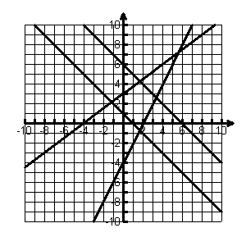
1
2
3
4
- Which lines have positive slopes?

- Which lines have negative slopes?

- Fill in the table by listing the coordinates for the x-intercepts and y-intercepts.

Line | x-intercepts | y-intercepts
1
2 |  | (0, 6)
3
4 | (-4, 0)

- Write the equation for line #1.

- Write the equation for line #2.

- Write the equation for line #3.

- Write the equation for line #4.

3.7.3 Y the X Are You Intercepting Me - Practice (Continued)

- Calculate the x and y-intercepts and graph each line on the graph paper on the next page.
a) 3x – 2y – 6 = 0

b) 5x + 2y – 10 = 0

c) 3x – y – 9 = 0

d) 2x – 5y – 14 = 0

3.7.3 Y the X Are You Intercepting Me - Practice (Continued)

Unit 3 Day 8: Slopes Away |  |  |  |  | Grade 10 Applied
Minds On: 20 Min. |  |  | Math Learning Goals  Students will:  - Determine the equation of a line, given the slope and y-intercept  - Given two points, write the equation of a line.  - Determine the slope of the line using rate triangles and the formula. |  | Materials  - BLM 3.8.1 – 3.8.4
Action: 35 Min. |  |  |  |  | Materials  - BLM 3.8.1 – 3.8.4
Consolidate/  Debrief: 20 Min |  |  |  |  | Materials  - BLM 3.8.1 – 3.8.4
Total = 75 Min. |  |  |  |  | Materials  - BLM 3.8.1 – 3.8.4
Assessment
Opportunities
 | Minds On… | Individual→Activating Prior Knowledge  Students review concepts learned so far in the unit using BLM 3.8.1.  Curriculum Expectations/Observation/Quiz: Assess students’ knowledge of linear systems. |  |  | Two colour counters may be used to help students who have difficulty subtracting integers.  Teacher may wish to introduce $m=\frac{y_{2}−y_{1}}{x_{2}−x_{1}}$after students have defined their own method of calculating slope.  Students can use a graphing calculator or CAS to verify their answers.
 | Action! | Pairs→ Think/Pair/Share  Students work on each question on BLM 3.8.2 individually and then compare their solutions with a partner. Students write their own method for determining slope given two points.  Strategy for Undefined Slope: Slope can be thought of as a measure of the difficulty of walking up an incline. A horizontal incline has zero difficulty. As the incline becomes steeper the difficulty increases. When the incline is vertical it is impossible to walk up it so the slope cannot be defined.  Pairs→A Coaches B  Students complete BLM 3.8.3. Partners alternate coaching to provide feedback.
 | Consolidate Debrief | Individual and Whole Class→Investigation  Students will continue with their new knowledge of calculating slope algebraically to write the equation of the line using BLM 3.8.4
Practice |  | Home Activity or Further Classroom Consolidation  Additional practice can be given as needed.

3.8.1 Writing Equations of Lines

Working with Another Form

Some Review
- What is the slope and y-intercept for each line?

a) y = -3x + 1  m = _______ b = ________ | b)  m = _______ b = ________

- Using this information, graph each of the equations on the grid below. Use a different colour for each line and label each line.
2
4
6
8
10
2
4
6
8
10
-2
-4
-6
-8
-10
-2
-4
-6
-8
-10

- Let's look at another two equations.

a) 3x + y – 1 = 0 | b) 3x – 4y – 12 = 0

What are two things you notice are different about these equations when you compare them to the equations in #1?

REMINDER:
You can only read the slope and y-intercept from the equation of a line if it is in y = mx + b form.
3.8.1 Writing Equations of Lines (Continued)

- Calculate the x-intercept and the y-intercept. Then graph the equations on the grid below. Use a different colour for each line and label each line.

a) 3x + y – 1 = 0 | b) 3x – 4y – 12 = 0

Practice:

- For each equation:
  - Calculate the x-intercept and the y-intercept.
  - Graph on the grid provided. Use a different colour for each line and label each line.

a) 2x + y – 4 = 0 | b) 4x + 2y + 6 = 0
2
4
6
8
10
2
4
6
8
10
-2
-4
-6
-8
-10
-2
-4
-6
-8
-10

3.8.2: Jack and Jill Go up a Hill
For each of the following questions
a) Plot the points on the given grid.
b) Draw a line connecting the points
c) Calculate the rise by counting squares. Calculate the rise again by using the coordinates of the points. Show your work to confirm your answers. (The first one is done for you).
d) Calculate the run by counting squares. Calculate the run again by using the coordinates of the points. Show your work to confirm your answers.
e) Calculate the slope. (rate of change)

1. A (0, 3) B (2, 0) | 2. C (-2, 0) D (0, 5) | 3. E (3, 0) F (0, -7) | 4. G (0, 0) H (7, 0)
Rise: 3 – 0 = 3  Run: 0 – 2 = -2  $$\text{Slope}=\frac{\text{Rise}}{\text{Run}}$$ | Rise:  Run:  $$\text{Slope}=\frac{\text{Rise}}{\text{Run}}$$ | Rise:  Run:  $$\text{Slope}=\frac{\text{Rise}}{\text{Run}}$$ | Rise:  Run:  $$\text{Slope}=\frac{\text{Rise}}{\text{Run}}$$
3.8.2: Jack and Jill go up a Hill (Continued)

Reminder: Vertical lines do not have a slope. The slope is undefined.

5. A (2, 3) B (5, 0) | 6. C (-2, 1) D (3, 5) | 7. E (2, 1) F (3, 6) | 8. G (-3,-3) H (-3, 7)
Rise:  Run:  $$\text{Slope}=\frac{\text{Rise}}{\text{Run}}$$ | Rise:  Run:  $$\text{Slope}=\frac{\text{Rise}}{\text{Run}}$$ | Rise:  Run:  $$\text{Slope}=\frac{\text{Rise}}{\text{Run}}$$ | Rise:  Run:  $$\text{Slope}=\frac{\text{Rise}}{\text{Run}}$$

Describe in your own words how you would calculate the slope of a line given two points without using a graph.

3.8.3: Slopes “A” way

A Coaches B | B Coaches A
9. A (25, 30) B (35, 20) | 10. E (-13, -23) F (31, 17)
$$\text{Slope}=\frac{\text{Rise}}{\text{Run}}$$ | $$\text{Slope}=\frac{\text{Rise}}{\text{Run}}$$
11. G (32, 21) H (-3, -16) | 12. A (7, 40) B (11, 81)
$$\text{Slope}=\frac{\text{Rise}}{\text{Run}}$$ | $$\text{Slope}=\frac{\text{Rise}}{\text{Run}}$$
13. E (3, 33) F (2, 27) | 14. G (-200, -100) H (30, -6)
$$\text{Slope}=\frac{\text{Rise}}{\text{Run}}$$ | $$\text{Slope}=\frac{\text{Rise}}{\text{Run}}$$
15. E (-12, -15) F (-20, -4) | 16. E (5, -6) F (15, 8)
$$\text{Slope}=\frac{\text{Rise}}{\text{Run}}$$ | $$\text{Slope}=\frac{\text{Rise}}{\text{Run}}$$
3.8.4: Writing Equations of Lines
For each of the following questions:
- Plot the points on the given grid.
- Draw a line connecting the points and extend the line in both directions to the edge of the graph.
- Calculate the slope (rate of change) using a formula. Compare your answer with your graph.
- Using the graph state the y-intercept.
- Write the equation of the line in slope y-intercept form.
- Verify your equation using a graphing calculator.
1. A (0, 8) B (8, 0)

$$\text{Slope}=\frac{\text{Rise}}{\text{Run}}$$

y-intercept =

Equation:
2. A (2, 4) B (4, 5)

$$\text{Slope}=\frac{\text{Rise}}{\text{Run}}$$

y-intercept =

Equation:
3.8.4: Writing Equations of Lines (Continued)
For each of the following questions:
- Plot the points on the given grid.
- Draw a line connecting the points and extend the line in both directions to the edge of the graph.
- Calculate the slope (rate of change) using the formula. Compare your answer with your graph.
- Using the graph state the y-intercept.
- Write the equation of the line in slope y-intercept form.
- Verify your equation using a graphing calculator.

3. A (-2, -2) B (2, 10)

$$\text{Slope}=\frac{\text{Rise}}{\text{Run}}$$

y-intercept =

Equation:
4. A (4, -6 ) B (12, 0)

$$\text{Slope}=\frac{\text{Rise}}{\text{Run}}$$

y-intercept =

Equation:
3.8.4 Writing Equations of Lines (Continued)
For each of the following questions:
- Plot the points on the given grid.
- Draw a line connecting the points and extend the line in both directions to the edge of the graph.
- Calculate the slope (rate of change) using the formula. Compare your answer with your graph.
- Using the graph state the y-intercept.
- Write the equation of the line in slope y-intercept form.
- Verify your equation using a graphing calculator.

5. A (-6, 4) B (5, 4)

$$\text{Slope}=\frac{\text{Rise}}{\text{Run}}$$

y-intercept =

Equation:
6. A (-6, 1) B (12, 4)

$$\text{Slope}=\frac{\text{Rise}}{\text{Run}}$$

y-intercept =

Equation:

Unit 3 Day 9 : Yes, We Have No Graph Paper! |  |  |  |  | Grade 10 Applied
Minds On: 10 Min. |  |  | Math Learning Goals  Students will:  - Write the equation of a line given a point and a slope or two points  - Write linear equations for relationships in context. |  | Materials  - Pattern blocks  - Nspire CAS handhelds  - BLM3.9.1-BLM3.9.4
Action: 20 Min.
Consolidate/
Debrief: 45 Min
Total = 75 Min.
Assessment
Opportunities
 | Minds On… | Pairs or Small Groups→Sequencing  Prepare strips found in BLM 3.9.1, one equation per group. Students are to arrange the strips in order to solve one variable linear equation.  Curriculum Expectations/Observation/Mental Note: Diagnostic assessment: Observe students as they sequence steps and provide appropriate intervention. |  |  | Teacher guidance or use of algebra tiles may be needed for some students that are experiencing difficulty.  Students should be encouraged to verify their answers using CAS or nearby students.  Provide pattern blocks to assist students who require a concrete model.
 | Action! | Whole Class→Teacher Directed Lesson  Teach the algebraic method of writing an equation given two points or one point and the slope. Note: Refer to Lesson 5 for assistance on using CAS.  Individual→Practice  Students complete BLM 3.9.2
 | Consolidate Debrief | Pairs→Investigate  Assign heterogeneous pairs. Students will complete one of four shape investigations from BLM 3.9.3. Pairs check answers with other pairs doing the same investigation.  Curriculum Expectations/Observation/Rubric: Assess students’ ability to gather data, calculate slope, y-intercept and write a linear equation
Reflection |  | Home Activity or Further Classroom Consolidation  Individual→Journal  Your best friend has called you for help on writing equations. They have been given two points. Explain to them two different ways to write the equation of the line. Students use BLM 3.9.4 to write journal response.
3.9.1: Solving Equations - Teacher


Equation 1 | Equation 2 | Equation 3
$\text{10}=3x−2$ | $$−\text{33}=5x+7$$ | $$0=2x+6$$
$$\text{10}+2=3x−2+2$$ | $$−\text{33}−7=5x+7−7$$ | $$0−6=2x+6−6$$
$$\text{12}=3x$$ | $$−\text{40}=5x$$ | $$−6=2x$$
$$\frac{\text{12}}{3}=\frac{3x}{3}$$ | $$\frac{−\text{40}}{5}=\frac{5x}{5}$$ | $$\frac{−6}{2}=\frac{2x}{2}$$
$$4=x$$ | $$−7=x$$ | $$−3=x$$
Equation 4 | Equation 5 | Equation 6
$$\text{15}=\text{14}+b$$ | $$\text{36}=−3+b$$ | $$\text{43}=−\text{10}x−\text{11}$$
$$\text{15}−\text{14}=\text{14}−\text{14}+b$$ | $$\text{36}+3=−3+3+b$$ | $$\text{43}+\text{11}=−\text{10}x−\text{11}+\text{11}$$
$$1=b$$ | $$\text{39}=b$$ | $$\text{54}=−\text{10}x$$
$$\frac{\text{54}}{−\text{10}}=\frac{−\text{10}x}{−\text{10}}$$ | $$\frac{−\text{27}}{5}=x$$ | $$−5\text{.}4=x$$

3.9.2 Yes, We got no Graph Paper!

Given points, the slope and/or the y-intercept, write the equation in y=mx+b form for each of the following:

A coaches B | B coaches A
Given:  slope = 5, y-intercept = 5 | Given:  M = -2, b = 3
Equation: | Equation:
Given:  Slope parallel to y = 2x – 7 with the same y-intercept as y = 4x – 10 | Given:  Slope parallel to x = 5 going through point A (2, 5)
Equation: | Equation:
Given:  Slope is 0, y-intercept = 5 | Given:  slope = 4, Point A (0, 3)
Work Shown: | Work Shown:
Equation: | Equation:
Given:  Point A (4, 3), Point B (-1, 3) | Given:  Point A (0, -1), Point B (4, 8)
Work Shown: | Work Shown:
Equation: | Equation:
Given:  Slope = $\frac{3}{5}$, Point (5, 7) | Given:  M = $\frac{−5}{3}$, Point A (5, 0)
Work Shown: | Work Shown:
Equation: | Equation:

3.9.2 Yes, We got no Graph paper! (Continued)

Given two points, the slope and/or the y-intercept, write the equation in y=mx+b form for each of the following:

A coaches B | B coaches A
Given:  Point A (10, 19), Point B (18, 31) | Given:  Point A (4, 6), Point B (7, 15)
Work Shown: | Work Shown:
Equation: | Equation:
Given:  Point A (5, 0), Point B (0, 200) | Given:  Point A (0, 5), Point B (200, 0)
Work Shown: | Work Shown:
Equation: | Equation:
Given:  Point A (1.5, 6.5), Point B (-1.5, -2.5) | Given:  Point A (1, 8.50), Point B (4, 28.50)
Work Shown: | Work Shown:
Equation: | Equation:

3.9.3: I’m on your side.
You will be assigned one of four shapes. Your job is to find the equation relating the number of shapes and the number of sides and then answer some other questions.

SQUARE INVESTIGATION
Start by placing squares side by side as shown. Note: This arrangement of 4 squares has 13 sides.
1 2 3 4
9 8 7 6
10 11 12 13 5

- Complete the following table relating the number of squares and total number of sides.

Number of squares (n) | Number of sides (s)
1 | Equation: s = ____ n + ______  (Remember: You need the slope and y-intercept. Use your knowledge to calculate these values.)
2
3
4 | 13
5
6
7

- Use your equation to calculate the number of sides that 50 squares placed side by side would have.

- Use your equation to calculate how many squares you would have if you counted all the sides and got a number of sides equal to 256?

3.9.3: I’m on your side. (Continued)

RECTANGLE INVESTIGATION
Start by placing rectangles side by side as shown. Note: This arrangement of 4 rectangles has 13 sides.
1 2 3 4
9 8 7 6
10 11 12 13 5

- Complete the following table relating the number of rectangles and total number of sides.:

Number of rectangles (n) | Number of sides (s)
1 | Equation: s = ____ n + ______  (Remember: You need the slope and y-intercept. Use your knowledge to calculate these values.)
2
3
4 | 13
5
6
7

- Use your equation to calculate the number of sides that 75 rectangles placed side by side would have.

- Use your equation to calculate how many rectangles you would have if you counted all the sides and got a number of sides equal to 724?

3.9.3: I’m on your side. (Continued)

HEXAGON INVESTIGATION
Start by placing hexagons side by side as shown. Note: This arrangement of 2 hexagons has 11 sides.
1
2
3
4
5
9
8
7
6
10 11

- Complete the following table relating the number of hexagons and total number of sides.

Number of hexagons (n) | Number of sides (s)  Equation: s = ____ n + ______  (Remember: You need the slope and y-intercept. Use your knowledge to calculate these values.)
1
2 | 11
3
4
5
6
7

- Use your equation to calculate the number of sides that 76 hexagons placed side by side would have.

- Use your equation to calculate how many hexagons you would have if you counted all the sides and got a number of sides equal to 1206?

3.9.3: I’m on your side. (Continued)

TRIANGLE INVESTIGATION
Start by placing triangles side by side as shown. Note: This arrangement of 3 triangles has 11 sides.
1
2
4 3
5 6 7

- Complete the following table relating the number of triangles and total number of sides.

Number of triangles (n) | Number of sides (s)
1 | Equation: s = ____ n + ______  (Remember: You need the slope and y-intercept. Use your knowledge to calculate these values.)
2
3 | 7
4
5
6
7

- Use your equation to calculate the number of sides that 76 triangles placed side by side would have.

- Use your equation to calculate how many triangles you would have if you counted all the sides and got a number of sides equal to 483?

3.9.4: I’m on your side.

Your best friend has called you for help on writing equations of lines. They have been given two points. Explain to them two different ways to write the equation of the line. You may use words, numbers or graphs in your explanation.

Unit 3 Day 10: So, You Think You Know Everything About Lines? |  |  |  |  | Grade 10 Applied
Minds On: 15 Min. |  |  | Math Learning Goals  Students will:  - Review x- and y-intercepts.  - Investigate the special cases x = a and y = b.  - Express the equation of a line in the form y = mx+b, given the form ax + by + c = 0. |  | Materials  - BLM 3.10.1- 3.10.6
Action: 40 Min. |  |  |  |  | Materials  - BLM 3.10.1- 3.10.6
Consolidate/  Debrief: 20 Min |  |  |  |  | Materials  - BLM 3.10.1- 3.10.6
Total = 75 Min. |  |  |  |  | Materials  - BLM 3.10.1- 3.10.6
Assessment
Opportunities
 | Minds On… | Pairs→Review Intercepts Worksheet  Distribute BLM 3.10.1. Students activate prior knowledge by completing the worksheet.  Whole Class→Discussion  Share student solutions and discuss student’s findings. |  |  | Refer to BLM 3.10.4 for directions on how to pair students for the two paired activities.
 | Action! | Pairs→Investigation  Distribute BLM 3.10.2 to the Horizontal group. Distribute BLM 3.10.3 to the Vertical group. Have students complete the worksheets in pairs.  Pairs→A Coaches B  Pairs coach their partner on the investigation they completed. Partner being coaches completes the appropriate BLM. Pairs switch roles and repeat for the other investigation.  Whole Class→Teacher Led Lesson  Using BLM 3.10.5 teach students how to convert from standard form of an equation to slope y-intercept form using prior knowledge on solving one variable equations using algebra.
 | Consolidate Debrief | Whole Class→Discussion  Consolidate student understanding on:  - horizontal and vertical lines  - converting from Standard Form to slope y-intercept form
Concept Practice |  | Home Activity or Further Classroom Consolidation  Students complete BLM 3.10.6 for further practice. |  |  | Use an exit ticket that has students make up their own Standard Form equation and convert it to slope y-intercept form.

3.10.1: So, You Think You Know Everything About Lines?
Review of Concepts

You’ve learned a lot up to this point in the unit, and to ensure that you still remember it, let’s do a little review. With your partner complete the following questions. Feel free to consult your notebook if you cannot remember.

1. What is a y-intercept? What is an x-intercept? | Give an example of each (in coordinate form).
2. Give an example of an equation in Standard Form. | How does the Standard Form make graphing easier for you?
3. If you graph the line using the Standard Form, how many intercepts do you have? | Can you graph a line any other way so that it will only have 1 intercept? (If so, sketch an example below.)
4. Is it possible to graph a line so that it will have no intercepts? Explain. | Is it possible to have more than 2 intercepts? Explain.

3.10.2: So, You Think You Know Everything About Lines? Horizontal Lines Investigation

With your partner complete the investigation below. You will be asked to coach someone later.

1. For the graph below, write the coordinates of each point on the graph in the table below.

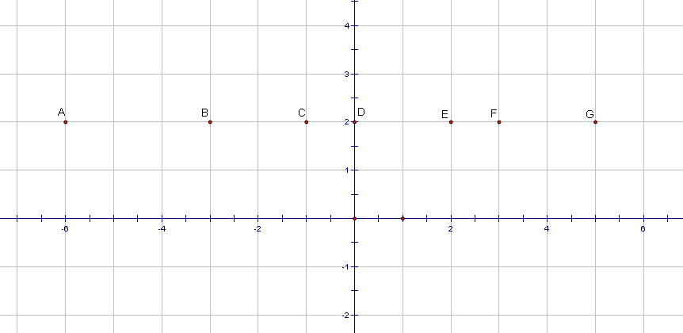

A ( _______ , ________ ) | B ( _______ , ________ )
C ( _______ , ________ ) | D ( _______ , ________ )
E ( _______ , ________ ) | F ( _______ , ________ )

G ( _______ , ________ )

2. What do all the points have in common?

3. There is only one point that has a coordinate of zero. What is another name for this point?

3.10.2: So, You Think You Know Everything About Lines? Horizontal Lines Investigation (Continued)

4. What is the equation of the line joining all the points? (Hint: The slope of the line is zero so the equation only depends on the value of the y intercept.)

5. What if all the points from the graph in question 1 shift up 2 units. What will your equation be now?

6. What if all the points from the graph in question 1 shift down 4 units. What will your equation be now?

7. Write the equation of the horizontal line that passes through:
a) (3,4) b) (-2,-4) c) (2.0)

8. Write a general equation for all horizontal lines? (Hint: Use b for the y-intercept)

3.10.3: So, You Think You Know Everything About Lines? Vertical Lines Investigation

With your partner complete the investigation below. You will be asked to coach someone later.

For the graph below, write the coordinates of each point on the graph in the table below.

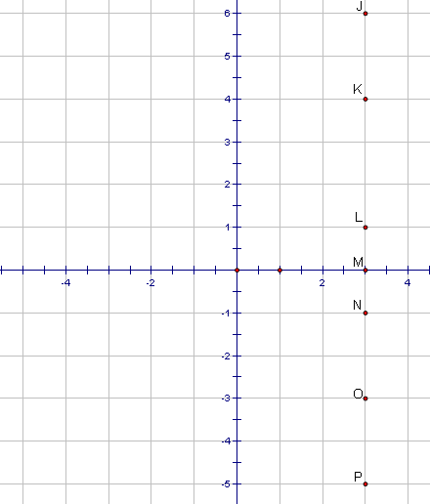

J ( _______ , ________ ) | K ( _______ , ________ )
L ( _______ , ________ ) | M ( _______ , ________ )
N ( _______ , ________ ) | O ( _______ , ________ )

P ( _______ , ________ )

2. What do all the points have in common?

3. There is only one point that has a coordinate of zero. Is there another name for this point?

3.10.3: So, You Think You Know Everything About Lines? Vertical Lines Investigation (Continued)

4. What is the equation of the line joining all the points? (Hint: The slope of the line is undefined so the equation only depends on the value of the x intercept.)

5. What if all the points from the graph in question 1 shift right 2 units. What will your equation be now?

6. What if all the points from the graph in question 1 shift left 4 units. What will your equation be now?

7. Write the equation of the vertical line that passes through:
a) (3,4) b) (-2,-4) c) (0.-1)

8. Write a general equation for all vertical lines? (Hint: Use a for the x-intercept)

3.10.4: Teacher Notes

Pairing Strategy for Horizontal and Vertical Lines Activities

Split the class into 2 heterogeneous groups with an equal number of students in each group. Name one group Horizontal, name the other Vertical.

Have each student in the Horizontal group spread their arms wide. Students measure their arm length against one another and arrange themselves in descending order (from widest arm span to shortest arm span). Then group students into pairs by starting with the student with the widest arm length. This student will be partner with the person next to him/her. The third person will be partner with the fourth person, and so on. If the group has uneven numbers, then have a group of three at the end.

Have each student in the Vertical group raise their arms straight over their heads. Students measure their vertical arm length against one another and arrange themselves in descending order (from the tallest overhead arm length to the shortest overhead arm length). Then group students into pairs by starting with the student with the tallest arm length. This student will be partner with the person next to him/her. The third person will be partner with the fourth person, and so on. If the group has uneven numbers, then have a group of three at the end.

Pairing Strategy for A Coaches B

The student with the widest arm span will pair with the student with the tallest arm length for the coaching activity. The partner of the student with the widest arm span will pair with the partner of the student with the tallest arm length. The third student in arm span will pair with the third student in arm length and so on.

Students with the completed horizontal worksheets will be Partner A. Students with the completed vertical worksheets will be Partner B.

Partner A will coach Partner B about horizontal lines. Partner B will coach Partner A about vertical lines.

3.10.6: Teacher Notes – Converting from Standard Form to Slope Y-intercept Form

There are times when an equation in Standard Form needs to be converted to an equivalent equation in Slope Y-intercept Form.

The advantages of Standard Form  (Ax + By + C = 0)  - x and y intercepts can quickly be determined  - graph can be quickly made | The disadvantages of Standard Form  (Ax + By + C = 0)  - rate of change (slope) is not immediately known  - fixed amount (y-intercept) is not immediately known

Using what we learned about solving equations in this unit we can convert an equation from Standard Form to Slope Y-Intercept Form. Here’s how:

- Write the equation in standard form
- Isolate the term containing y by adding or subtracting to both sides the term containing the x term
- Complete isolation of the term containing y by adding or subtracting to both sides the term containing the number term
- Divide both sides of the equation by coefficient of the term containing y. If the division does not result in an integer write terms with fractions in lowest terms.

Example 1:
2x + 3y + 6 = 0
2x + 3y + 6 – 2x = 0 – 2x
3y + 6 – 6 = -2x -6
3y = -2x – 6
y = -2/3 x -6/3 (because the whole right hand side is being divided by 3)
y = -2/3 x – 2 (simplify)

Example 2:

6x + 3y - 12 = 0
6x + 3y – 12 – 6x = 0 – 6x
3y -12 + 12 = -6x + 12

3y = -6x + 12

y = -6/3 x + 12/3

y = -2 x + 4 (point out to students that sometimes the numbers work out nicely, but if not, then leave the numbers in fractions form)

Example 3:

-4x – 5y – 7 = 0
-4x – 5y – 7 + 4x = 0 + 4x
-5y – 7 + 7 = 4x + 7

- 5y = 4x + 7

y = 4/5 x + 7/5 (because the fractions cannot be reduced, leave them as they are)

3.10.6 Converting from Standard to Slope Y-Intercept Form – Practice

- Convert the equations below into slope y-intercept form.
a) 3x + y – 1 = 0 | b) 3x – 4y – 12 = 0

- Now, state the slope and y-intercept for each equation.
a)  m = _______ b = ________ | b)  m = _______ b = ________

- For each equation:
  - Convert to slope y-intercept form
  - State the slope and y-intercept.
  - Graph on the grid provided. Use a different colour for each line. Label each.

a) 2x + y – 4 = 0  m = ___ b = ___ | b) 4x + 2y + 6 = 0  m = ___ b = ___ | c) x – y – 5 = 0  m = ___ b = ___ | d) 3x + 2y – 8 = 0  m = ___ b = ___
2
4
6
8
10
2
4
6
8
10
-2
-4
-6
-8
-10
-2
-4
-6
-8
-10

Unit 3 Day 11: London Bridge Is Falling Down… |  |  |  |  |  | Grade 10 Applied
Minds On: 5 Min. |  |  | Math Learning Goals  Students will:  - Collect data on linear relations in context of real-life problems  - Determine the equation of the linear relation  - Relate the slope and intercepts in the context of real-life applications |  |  | Materials  - Graphing Calculators (optional)  - 200 Linking Cubes or pennies  - Plastic Cup  - Masking Tape  - Rulers  - Scissors
Action: 60 Min.
Consolidate/
Debrief: 5 Min
Total = 75 Min.
Assessment
Opportunities
 | Minds On… | Groups → Matching Models  Students are given cards from BLM 3.11.1. Each student will receive either an equation in y=mx+b, a slope/y-intercept, or an equation in standard form. Once all the cards are given out, students are to form groups with other students whose cards represent the same line. (3 in a group). |  |  | Teacher should have BLM 3.11.1 cut out before class. Make sure the cards are mixed up before handing the cards out.  Some website you can observe on bridges: http://www.pbs.org/wgbh/nova/bridge/ or http://www.sciencebuddies.org/science-fair-projects/project_ideas/CE_p011.shtml?from=Home  It might be better to cut all the paper you need a head of time (BLM 3.11.3). You will need 6 halves for each group  If linking cubes are not present you might want to use pennies.  It would be better to use 12 oz large plastic cups  A possible extension is for students to create a different bridge model an perform the cube collapse test.
 | Action! | Group→Investigation  The teacher may want to introduce this activity though discussion on bridge design and what determines what a good bridge design (you may use BLM 3.11.2 or various websites).  Students will work in groups of 3 based on the grouping from BLM 3.11.1. Each group member will have a task based on their Minds On card. Students will collect data relating the layers in the bridge to the number of cubes it takes for the bridge to collapse. Students record their data on (BLM 3.11.3). If students do not get linear data, BLM 3.11.4 can be an intervention.  Students will then use their data to create a scatter plot, determine equations of the line of best fit fro both bridge models. They will then extrapolate and interpolate various values from their algebraic model and identify the significance of the slope in the context. Students will then answer various questions involving the standard form of a line, and intercepts.  Students can also hand this activity in as part of their summative assessment for unit 3. Calculators can also be used to verify their equations.  Mathematical Process Focus: Connecting (Students will connect, slope, intercepts and equations to real-life contexts)
 | Consolidate Debrief | Whole Class→Sharing  Take up the review questions from lesson 3.10. Students share a variety of solutions to homework problems. Identify and address any misconceptions.
Concept Practice  Application |  | Home Activity or Further Classroom Consolidation  Students work on the unit review to prepare for the unit summative assessment task or a pencil and paper test. |  |  | A sample unit summative task is found in unit 8 in the members area of the OAME web site.
3.11.1: Hand In Hand Together -Teacher Note

- Each student will receive a card listed below, copied onto an index card or cut into sections in advance.
- Organize the classroom so that all slopes are located in one area, all y=mx+b cards are located in another area etc. with a row of single desks separating each group (see diagram below).
- Students are to remain in their area and can only speak with the group directly beside them. Thus, Slope & y-intercept students can talk to both groups but Y-intercept Slope Form students can’t speak with the Standard Form students. They will need to co-operate with each other to find their proper matches.
- Once they have found their matches they are to hold hand in hand across the desks to form a bridge.
- Note: You might want to consider giving the stronger students the middle card.

Classroom Set Up:

Y-intercept Slope Form Students | Desk | Slope & Y-intecept Students | Desk | Standard Form Students
Y-intercept Slope Form Students | Desk | Slope & Y-intecept Students | Desk | Standard Form Students

Cards:

Y-intercept Slope | Slope & Y-intercept | Standard
$$y=\frac{−3}{2}x+2$$ | $m=\frac{−3}{2}$, (0, 2) | 3x + 2y – 4 = 0
$$y=\frac{5x}{3}+2$$ | $m=\frac{5}{3}$, (0, 2) | 5x – 3y + 6 = 0
$$y=\frac{−3x}{2}+4$$ | $m=\frac{−3}{2}$, (0, 4) | 3x + 2y – 8 = 0
$$y=\frac{5x}{3}−3$$ | $m=\frac{5}{3}$, (0, -3) | 5x – 3y – 9 = 0
$$y=\frac{−x}{4}+4$$ | $m=\frac{−1}{4}$, (0, 4) | x + 4y – 16 = 0
$$y=\frac{−x}{4}−3$$ | $m=\frac{−1}{4}$, (0, -3) | x + 4y + 12 = 0

3.11.2 London Bridge Is Falling Down…Introduction

Introduction to Bridge Building

There are many different types of bridge designs which serve different purposes. The factors that determine the bridge design includes the type of traffic (i.e. more trucks or cars), what is under the bridge, the aesthetics and the cost.

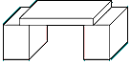 | Beam or Plank Bridge
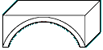 | Arch Bridge
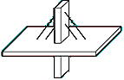 | Cable-Stayed Bridge
 | Suspension Bridge
Source: Images are taken from: NOVA Online http://www.pbs.org/wgbh/nova/bridge/build.html

Before a bridge is constructed, engineers design models to ensure that the bridge can withstand the stress of the load from cars and people.

In today’s activity, you will be working in groups of three. Your group will construct two bridge designs out of paper: the Plank Bridge and the Arch Bridge. Using linking cubes, you will record the number of cubes needed to make each bridge collapse at various paper thicknesses.

Group Member Responsibilities

Name | Minds On Card | Appointed Job
 | y = mx + b | Data Recorder  Records information from the activity
 | Slope and Y-intercept | Materials Manager  Collects all the materials needed  Prepares paper and books
 | Standard Form | Model Designer  Creates each bridge model and adds the load to the bridge model
3.11.3 London Bridge Is Falling Down… Instructions

Preparation Instructions

- Have the materials manager collect 30 linking cubes, a piece of masking tape, a plastic cup and 6 pieces of paper. (Your teacher may have already cut the paper for you by cutting a standard sheet of 8.5” x 11” in half as shown below).

- Fold 5 pieces of paper as shown below. These will be call you bridge planks.

8.5”
2 cm
2 cm

- Place a piece of masking take 2 cm from the edge of two textbooks. Make sure the spines of each book are facing outside as shown below.

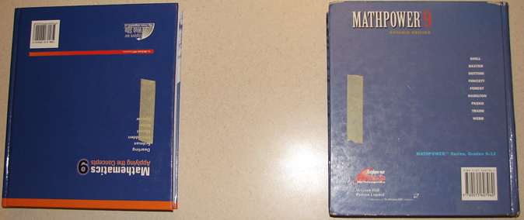
2 cm
2 cm

3.11.3 London Bridge Is Falling Down…Instructions (Continued)

Beam Bridge Instructions

- Place the first bridge plank such that the ends of each plank touch the masking tape as shown below.
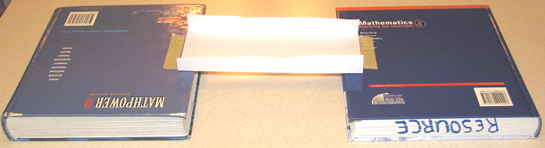

- Next, place the plastic cup in the middle of the Beam Bridge.
- Place a linking cube into the cup gently. Continue placing one linking cube at a time until the bridge collapses. The bridge must touch the desk for it to be considered a collapse.
- Record this data on the data collection sheet provided.
- Place another plank over top the first one creating a two layer plank bridge.
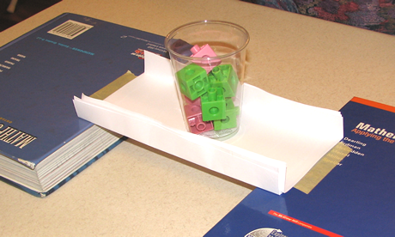
- Place the empty cup in the middle of the bridge.
- Repeat step 6 – 7
- Repeat steps 8 – 10 for a 3, 4, and 5 layer plank beam bridge.

3.11.3 London Bridge Is Falling Down…Instructions (Continued)

Arch Bridge Instructions

- The next design is to create an arch bridge. Using the same textbooks and setup as the last bridge, place the unfolded piece of paper between the textbooks to form an arch as shown below.
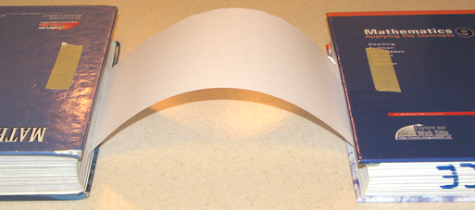

- Place one of the planks from the last activity on top of the arch making sure the ends of the plank coincide with the tape.
- Place the empty cup in the middle of the plank.
- Add linking cubes, one at a time until the bridge collapses.
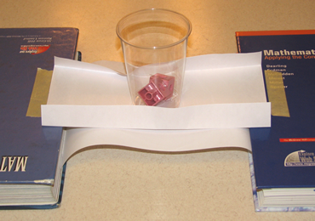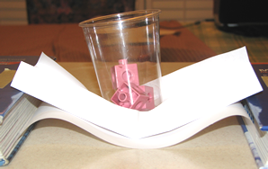
- Record this data on the data collection sheet provided.
- Place another plank over top the first one creating a two layer plank bridge.
- Place the empty cup in the middle of the bridge.
- Repeat step 4 – 5
- Repeat steps 6 – 8 for a 3, 4, and 5 layer plank arch bridge.

3.11.3 London Bridge Is Falling Down…Instructions (Continued)

London Bridge Is Falling Analysis

Data Tables
- Place the data from your investigation on the tables below

BEAM BRIDGE
Number of Planks | Number of Cubes
ARCH BRIDGE
Number of Planks | Number of Cubes
Graphs:
- Use this grid for the questions below.
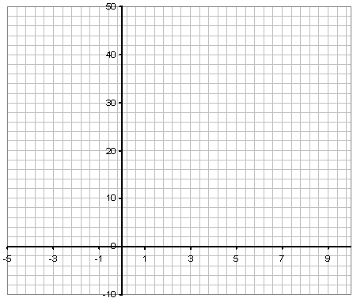
3.11.3 London Bridge Is Falling Down…Instructions (Continued)

Calculations:
- What variable is the x-variable (independent) (Circle one): Number of Planks or Number of Cubes
- What variable is the y-variable (dependent) (Circle one): Number of Planks or Number of Cubes
- Create a scatter plot from the data of both bridges using a different colour for each data set. Label axes with appropriately.
- Create lines of best fit for both sets of data using a different colour for each line.
- From the Beam Bridge line of best fit, choose two points. Calculate the slope using these two points.

m =
- Explain the significance of the slope in the context of this activity.

- Using the slope and coordinates of one of the two points calculate the y-intercept by substituting into y=mx+b and solving for b.

b =
- Write the equation of the Beam Bridge.

3.11.3 London Bridge Is Falling Down…Instructions (Continued)

- From the Arch Bridge line of best fit, choose two points. Calculate the slope from these two points.

m =

- Explain the significance of the slope in the context of this activity.

- Using the slope and coordinates of one of the two points calculate the y-intercept by substituting into y=mx+b and solving for b.

b =

3.11.3 London Bridge Is Falling Down…Instructions (Continued)

- Write the equation of the Arch Bridge.

- You want to be sure that a bridge can hold 100 cars at one time. If each car is represented by a linking cube, how many planks would your bridge need? Show work below.
Beam Bridge | Arch Bridge
- You recently saw two bridges hold 250 “cars” at once. How many planks would be required to hold those cars for both bridges? Show work below.
Beam Bridge | Arch Bridge

3.11.3 London Bridge Is Falling Down…Instructions (Continued)

Reflection:
- What are the x-intercepts of both graphs? Interpret their significance in the context of this activity.

- Which bridge presents a better design? Offer mathematical proof using data you collected and calculations you did.

- One of your friends says the she constructed an amazing bridge but the plans were lost. The only thing left was the equation:
5x – 3y + 15 = 0
  - Graph this equation on the grid with your other two graphs
  - Using the graph, does this equation ever cross one of the other lines? What do these points mean in the context of this problem?

  - Based on the graph and the equation, is your friends bridge better, worse or the same as the Beam bridge? Offer mathematical proof.

  - Based on the graph and the equation, is your friends bridge better, worse or the same as the Arch bridge? Explain using mathematics.

3.11.4 London Bridge Is Falling Down… - Teacher Note

Below is a set of data based on this activity. You may choose to use this as an intervention for groups that do not get linear data.

Number of Planks | Number of Cubes-  BEAM BRIDGE | Number of Cubes-  Arched Bridge
1 | 2 | 3
2 | 6 | 9
3 | 11 | 16
4 | 17 | 23

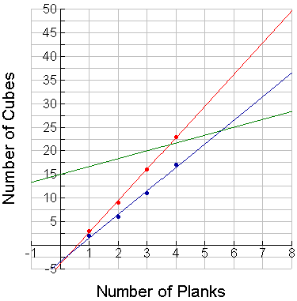
5x – 3y + 15 = 0
Beam Bridge
y = 5x – 3.5
Arched Bridge
y = 6.7x – 4

- The slope represents the number of cubes one can place per added plank.

- The y-intercept’s meaning is much more abstract. In this context: the number of cubes needed to make the bridge collapse when no planks are used.

- The x-intercept has contextual meaning: the number of planks required when the bridge collapses on itself (i.e. this Beam Bridge has an x-intercept of 0.7 which means that a plank that is 0.7 thickness will collapse on its own weight)

Unit 3 Equations of Lines Review

1. On a Cartesian coordinate system, plot and label the following points.

A = (2,-1) B = (4, 10) C = (1, 7) D = (2,-3)

a) Draw the following lines: AB AC BC CD

- Calculate the slope for each line using a rate triangle:

Slope (AB) = Slope (AC) =

- Calculate the following slopes algebraically. Verify with the graph.

Slope (BC)= Slope (CD)=

2. Comparison of Slopes

a) If a line slants upward from left to right, it has a slope.

b) If a line slants downward from left to right, it has a slope.

Unit 3 Equations of Lines Review (continued)

3. Draw two examples of lines with a positive slope and two examples of lines with a negative slope in the corresponding grids below.

Lines With Positive Slopes | Lines With Negative Slopes

- Circle the equations of the lines that are horizontal.
Underline the equations of lines that are vertical.

a) x=7 | b) y=3 | c) x=-3
d) y=5 | e) y=3x+6 | f) y=-2

5. Complete the sentences by filling in the blanks.

Horizontal Lines
a) The equations of all horizontal lines are of the form ___________.

b) The slope of a horizontal line is _________________.

c) Horizontal lines do not cross the ___ axis.

Vertical Lines
a) The equations of all vertical lines are of the form _____________.

b) The slope of a vertical line is ____________________.

c) Vertical lines do not cross the ___ axis

Unit 3 Equations of Lines Review (continued)

6. Write the equation of each line.  A: ______________________  C: ______________________  E: ______________________  F: ______________________  B  A  C  D  E | 7. Graph and label the lines.  A: x = 3  B: y = -6  C: y = 5  D: x = -6

8. a) When the equation of a line has the form y=mx+b,
m is the __________ of the line and
b is the ________________.

b) State the slope and coordinates of the y-intercept for each.
i) y =$\frac{2}{5}$x - 4 ii) y = -3x iii) y = -2x + 5 iv) y = -3

9. Write the equation of each line given:

a) slope 5 and y-intercept 3 | b) b= 7 m = -½
c) slope of -2 and passing through A(0, 4) | d) slope parallel to y = 3x + 7 with same y-intercept as y = 8x –19

Unit 3 Equations of Lines Review (continued)

10. Find the equation of each line.
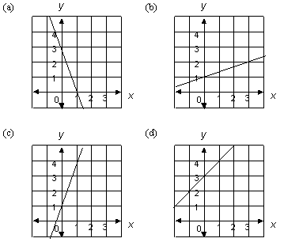

(a) ________________

(b) ________________

(c) ________________

(d) _________________

11. State two possible equations for each line.

y y
a) b)

x x

1)__________________________ 1)___________________________

2)__________________________ 2)___________________________

c) Justify your choices for m and b:

Unit 3 Equations of Lines Review (continued)

12. Draw rough sketches of the following lines showing the y-intercept and slope triangle for each.

a) $y=\frac{2}{3}x+1$

b) $y=\frac{1}{5}x−2$

c) $y=−3x+2$

d) $y=−\frac{7}{5}x−3$

Answer the following questions based on the lines graphed below.
1
2
3
4
- Which lines will have positive slopes?

- Which lines will have negative slopes?

- Fill in the table by listing the coordinates for the x-intercepts and y-intercepts.
Line | x-intercepts | y-intercepts
1
2 |  | (0, 6)
3
4 | (-4, 0)

Unit 3 Equations of Lines Review (continued)

16. How does knowing the x-intercept and y-intercept help you to graph a line?

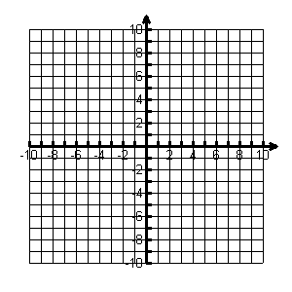

17. Graph the following lines by finding the x and y-intercepts.

a) 3x – 2y – 6 = 0 | b) 2x – 5y – 14 = 0

18. Find the equation of the line given the point and slope.

a) (2, 1); m = 3 b) (-3, 4); m = ¾

c) (4,-5); m = -1 d) (5, 0); m = -6

19. Find the equation of the line joining the two given points.

a) (2, 1); (-3, 4); c) (4,-5); (5, 0);

Unit 3 Equations of Lines Review (continued)

Scenario | 1.Babysitting Earnings  A family pays the babysitter $4.00/hr, plus a tip of $5.00. | 2. Bank Account Balance  A bank account is opened with a balance of $900. Each week $150 is withdrawn from the account. | 3. Car Rental Costs  Rent-A-Ride charges a flat fee of $55 plus $0.25/km to rent a car.
Introduce Variables | Let x =  Let y = | Let x =  Let y = | Let x =  Let y =
Equation in the form of y=mx+b
In real-life terms, what is the y-intercept?
What would be the real-life implication of a greater y-intercept?
What would be the real-life implication of a smaller y-intercept?
In real-life terms, what is the rate of change (m)?
What would be the real-life implication of a greater (steeper) rate of change?
What would be the real-life implication of a smaller (flatter) rate of change?

